**Basic processes in visual perception**

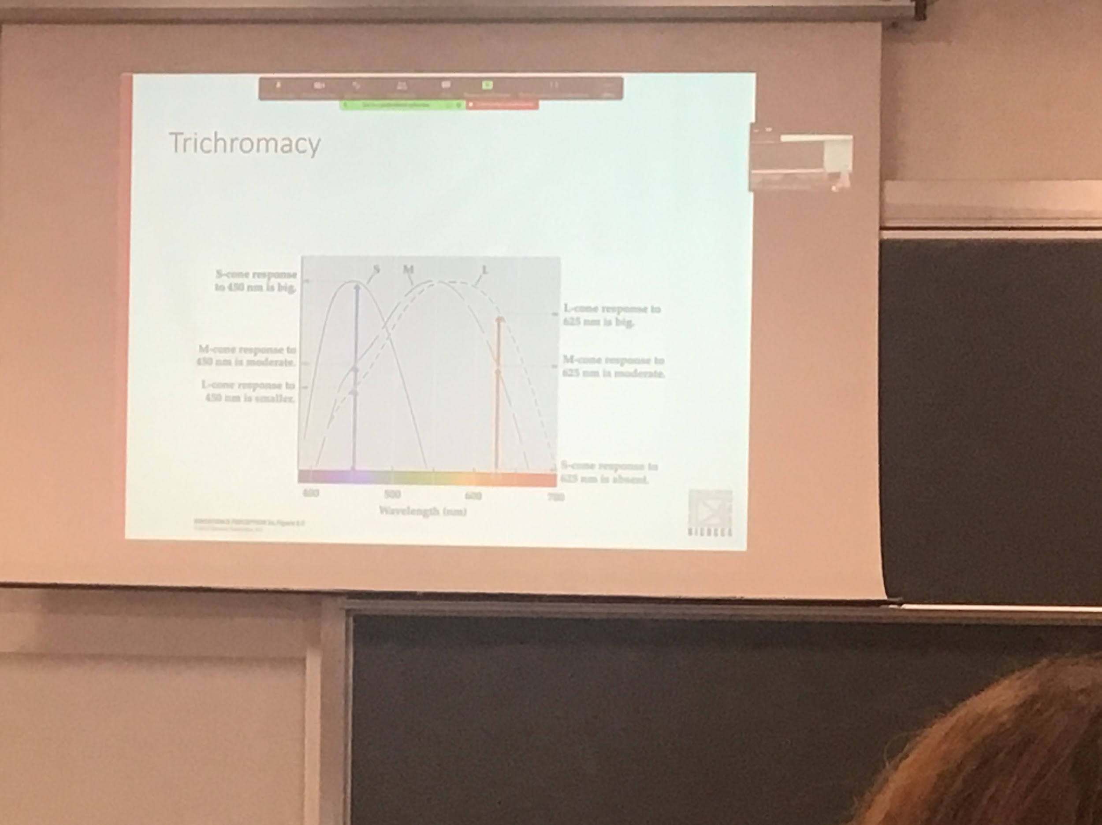

The reason why we see colour is because of specific photoreceptors that codes differently the wavelets distribution presence in the light that reach the eye

Three cones that have different responses to the wavelength of the spectrum

With three photos receptor we can code different mixture of wavelengths, three codes have a preferential wavelength

S, M, L short medium long

Blue: codes the lower ranges

Red and Green does higher ranges

Our vision is tricomomatrical

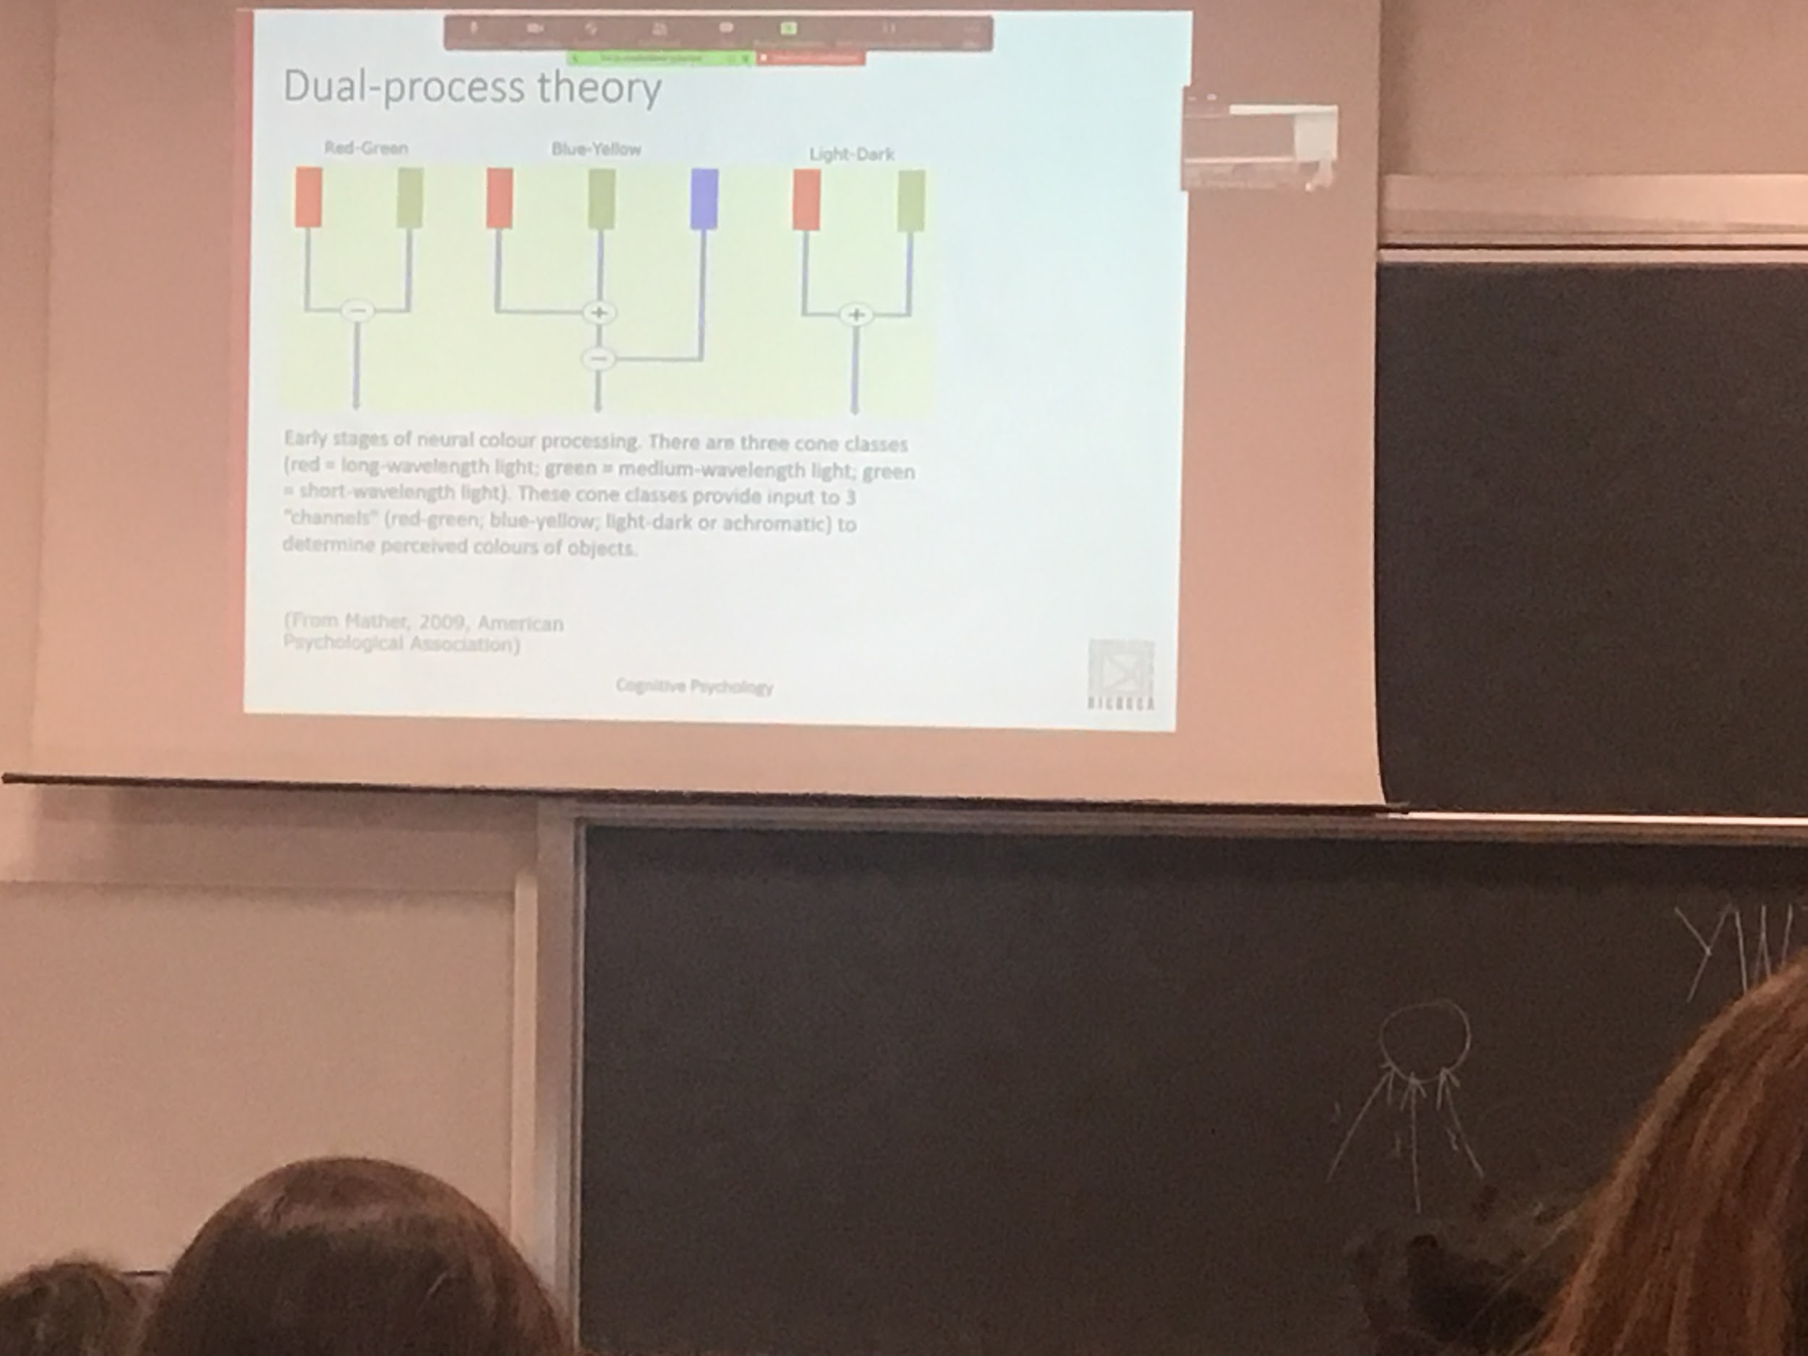

There are some situations (colour opponency…) that can not be explained just by the presentence of three condos, we need opponent challenges

**Dual process theory**, three opposed channels

* red & green: contrast the responses of the red and green cones. Difference between activity levels in the medium and long wavelength cones
* Blue & yellow: difference between the sum of the medium and long wavelength cones and the short wavelength
* Light & dark: combines activity of the medium and long wavelength cones

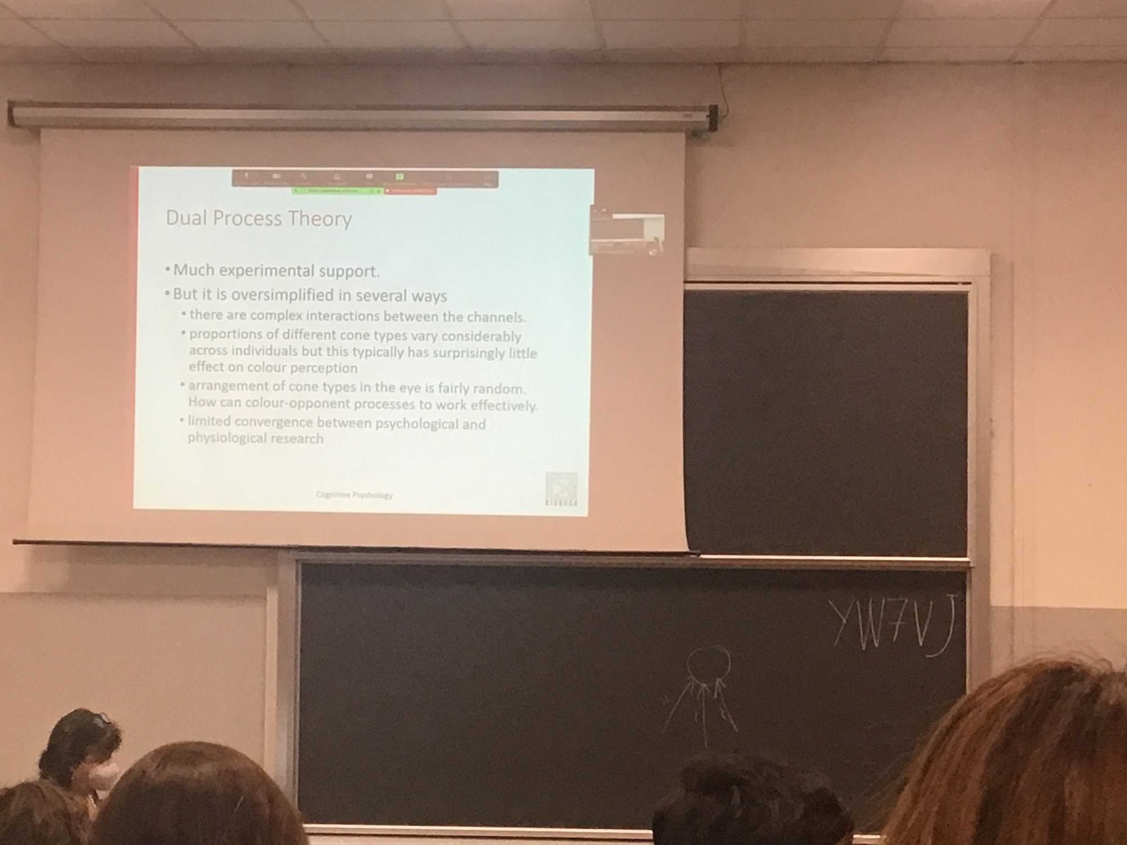

This theory is oversimplified

There are interactions in the channels (not so pure), if we look at the distribution of the 3 cones there are much differences people, but don’t discriminates the ability to see colours

If we see the distributed blue cones are very rare (not distributed evenly) is stangee how the system works. We still have to make connections between the psychological data and the psychological research that show that there is no even distribution

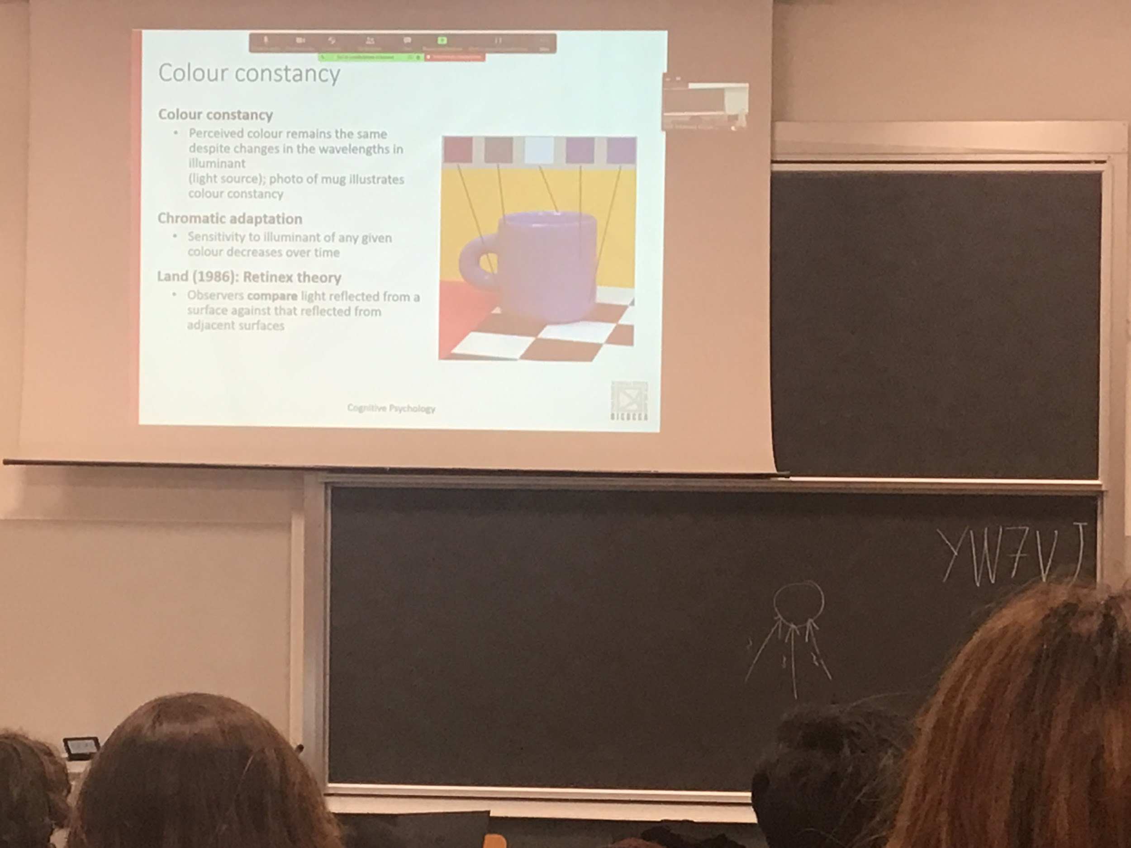

The illumination is what allows us to see, we need an illuminant to see, different illuminations makes light come from different part of the object in different way

We also have shaodow, most of the objects are not transparent, interfere with the direction of the light

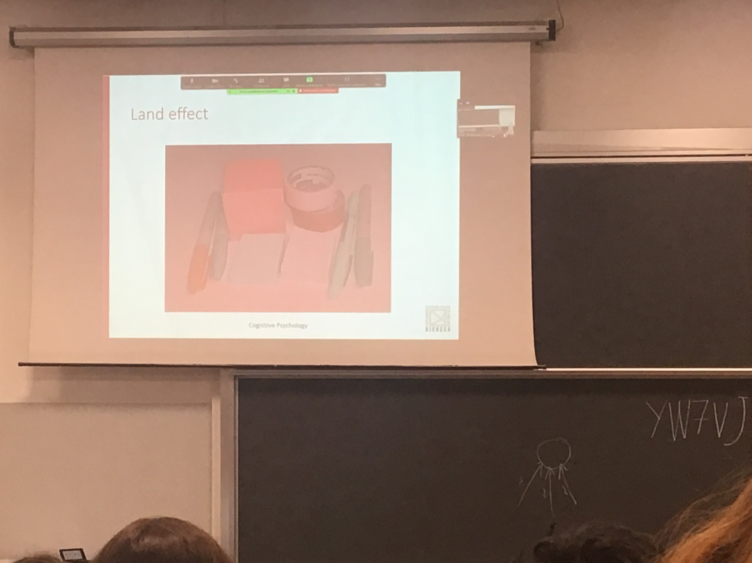

Land effect: we have the feeling, we use the constraints between surfencens, we try to discount the luminance to perceive the real colour of the object.

The system try to takes away the red information, this is also a proof that our brain does computations, is not straightforward informations

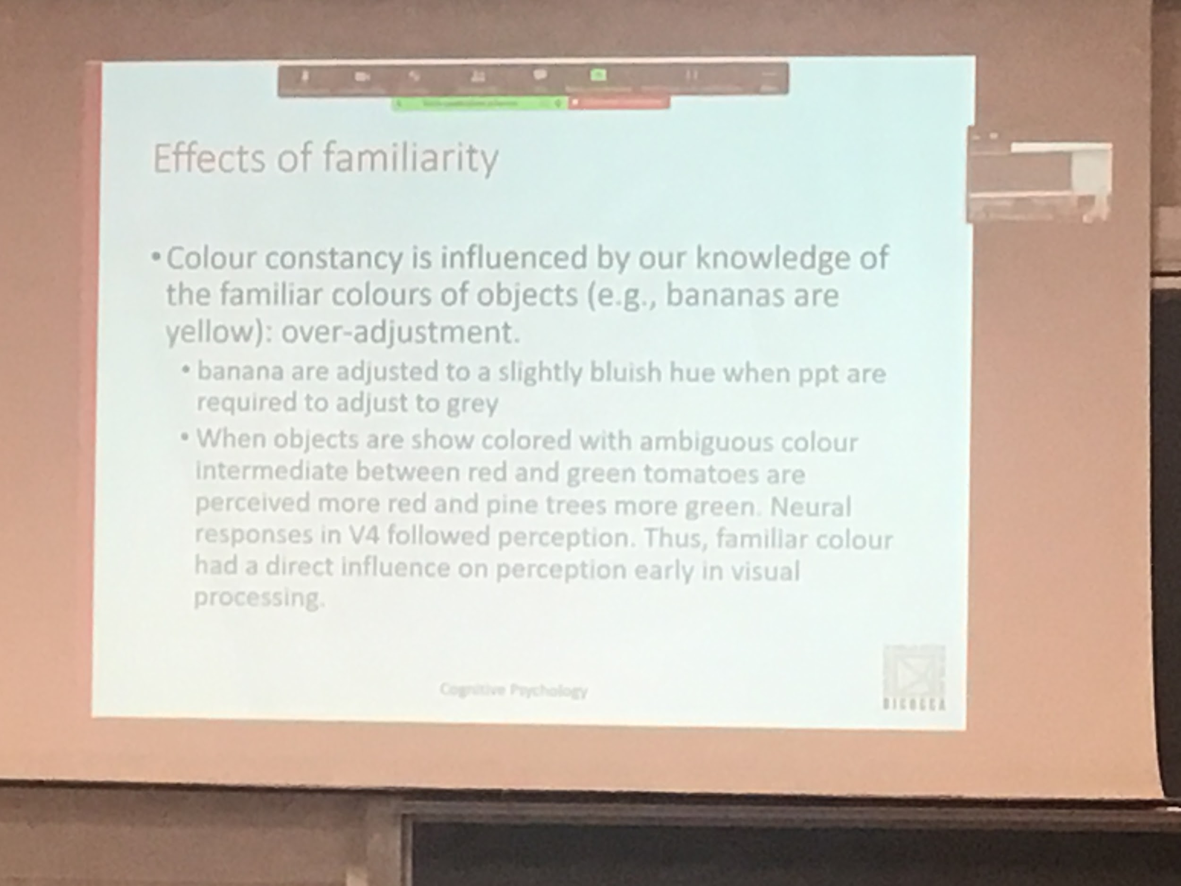

Yellow banana on black, if we can adjust the colour. If we are asked to have the image grey we usually overdjust

We overcompensate, our idea is that the banana is yellow

Your experience influence our perception

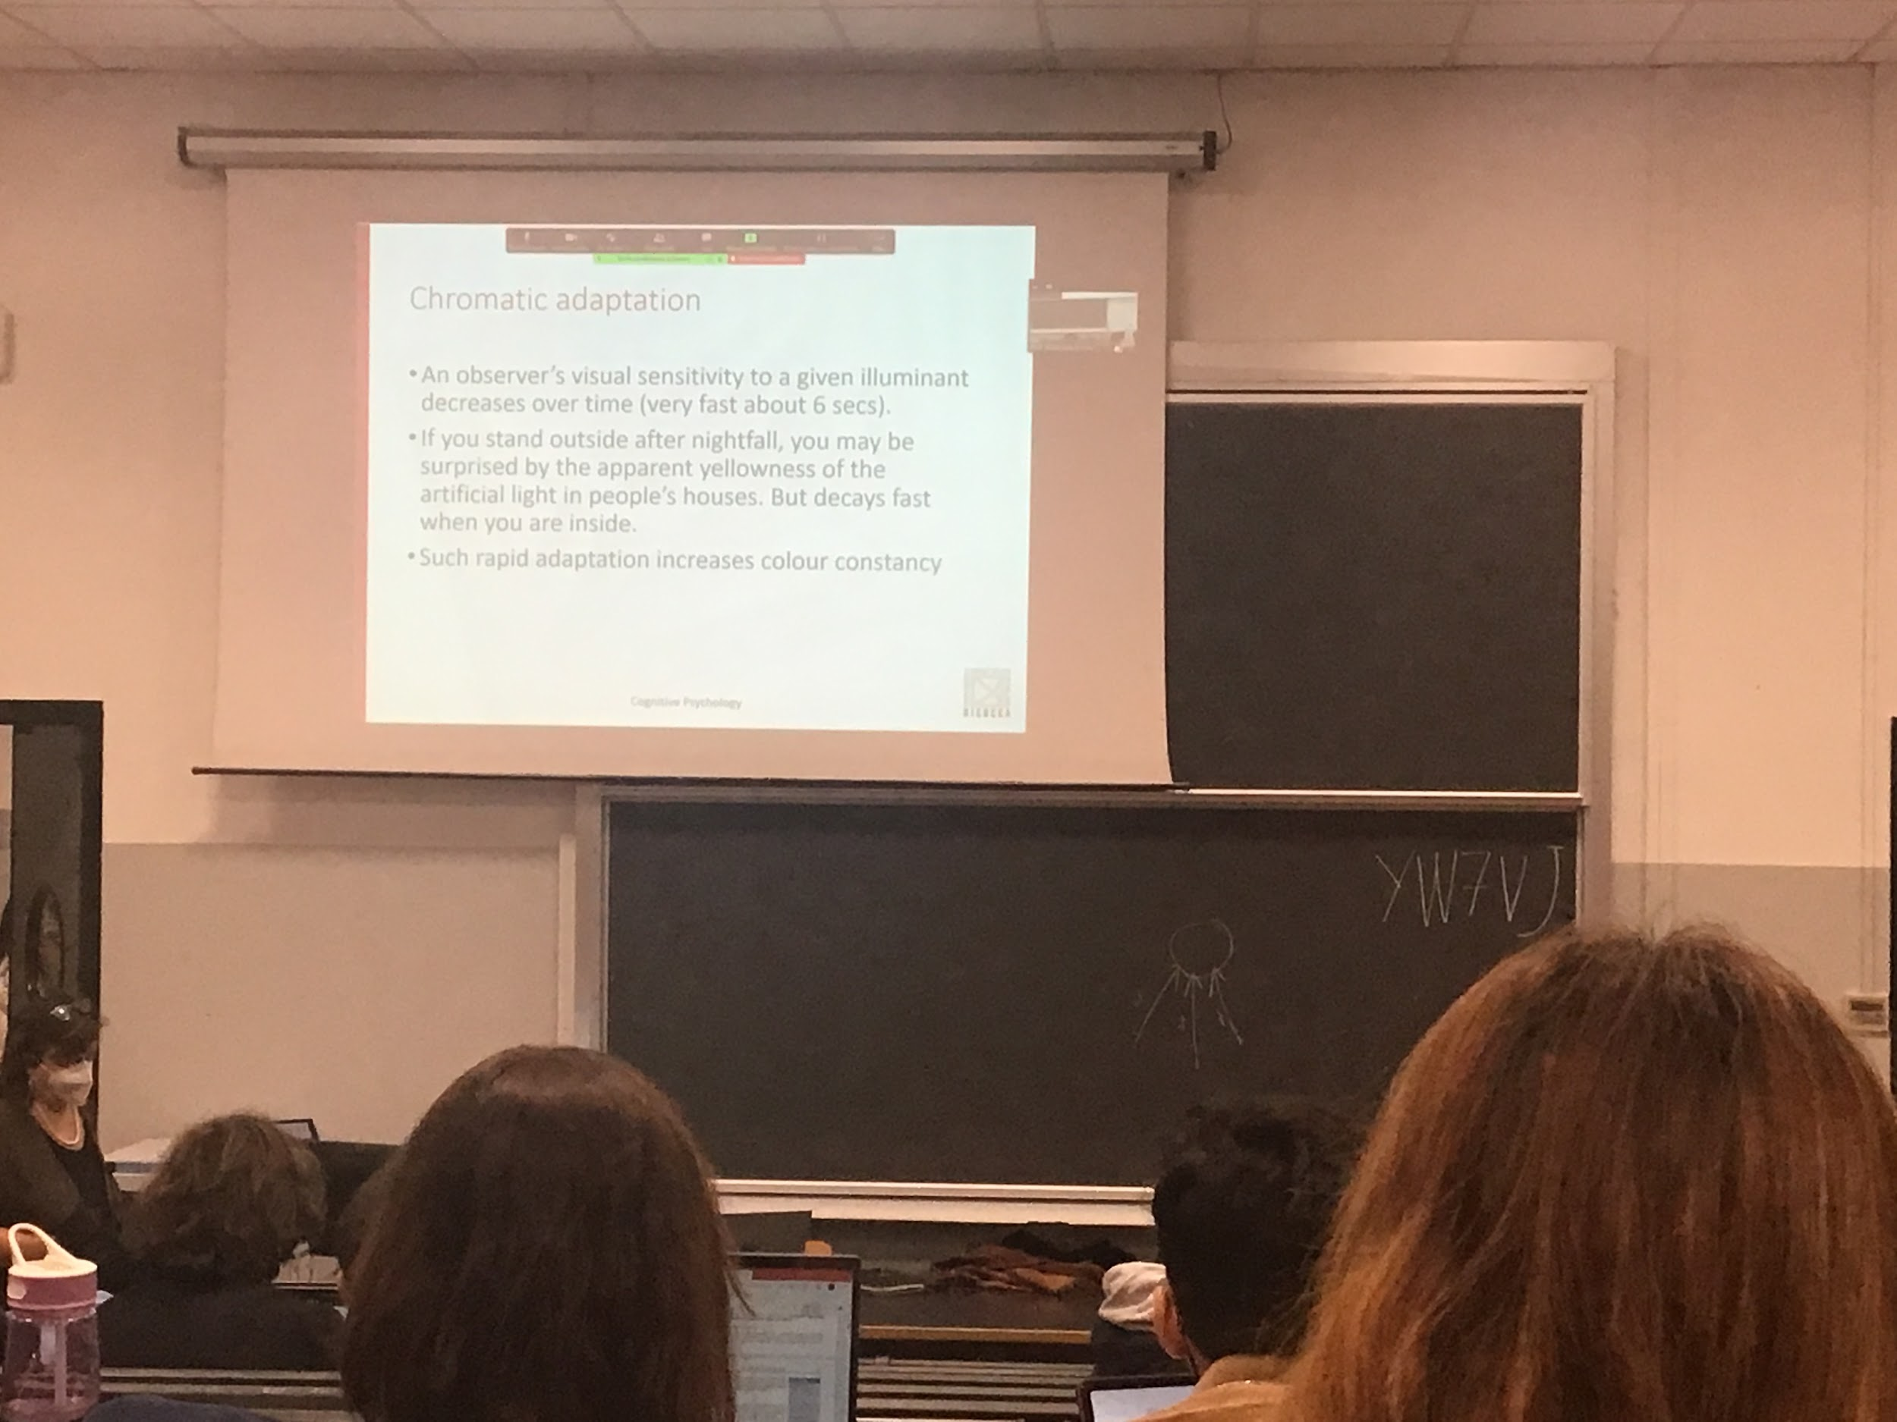

Chromatically adaptation: very fast, one wave to take away informations about the luminance

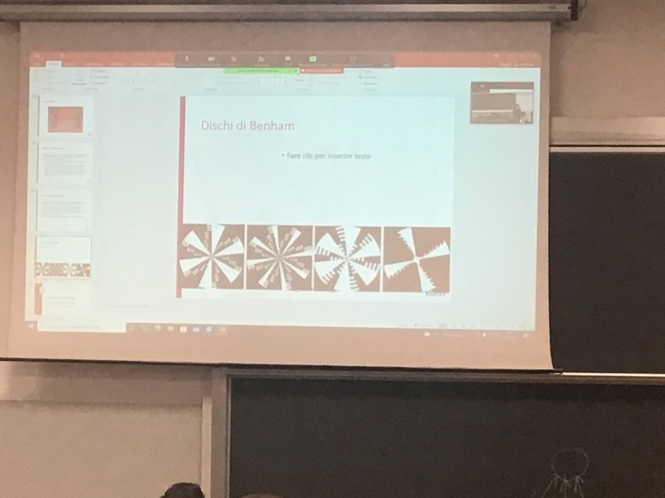

colour is intempration: there is no colour, different photoreceptors have difference speed of adaptation

**Basic processes in visual perception depth perception**

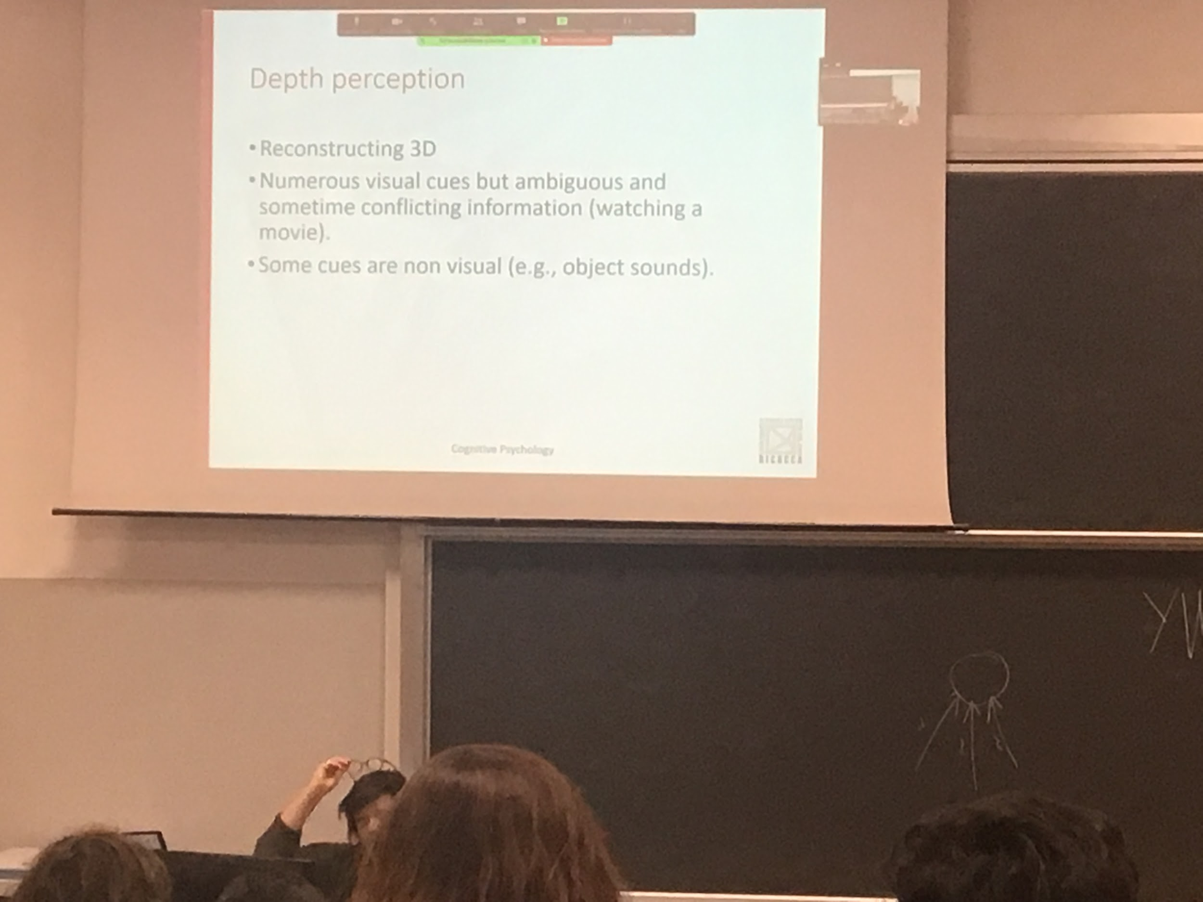

The problem that the system has with the interpretation of the signal that come from the eye is that if has to reconstruct a 3D word coming from 2D

The photoreceptors codes the presence of a light coming from different direction

The brain has develop from using all possible clues for extract different informations from the environment

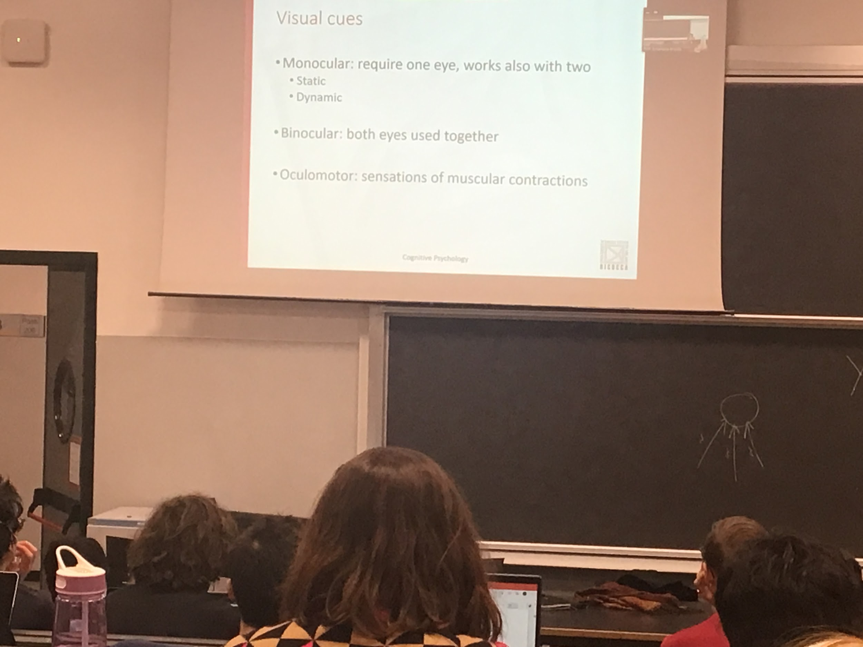

All the cues are combined in some way, there are 3 larger category of cues

* monocular: information that is present in one of the images (close 1 eye). Divided in 2 groups
  + Static: monocular cues, suggest the presence of depth, without you moving
  + Dinamic: either you move wrt something or the object move toward you
* Binocular: clues that works when you put glasses on in a 3d movie
* Oculomotor, the system compute depths of a given object using activity of the muscle in the eye by changing size of lenses
  + Size on lenses
  + Muscle that help you converge or diverge the eye

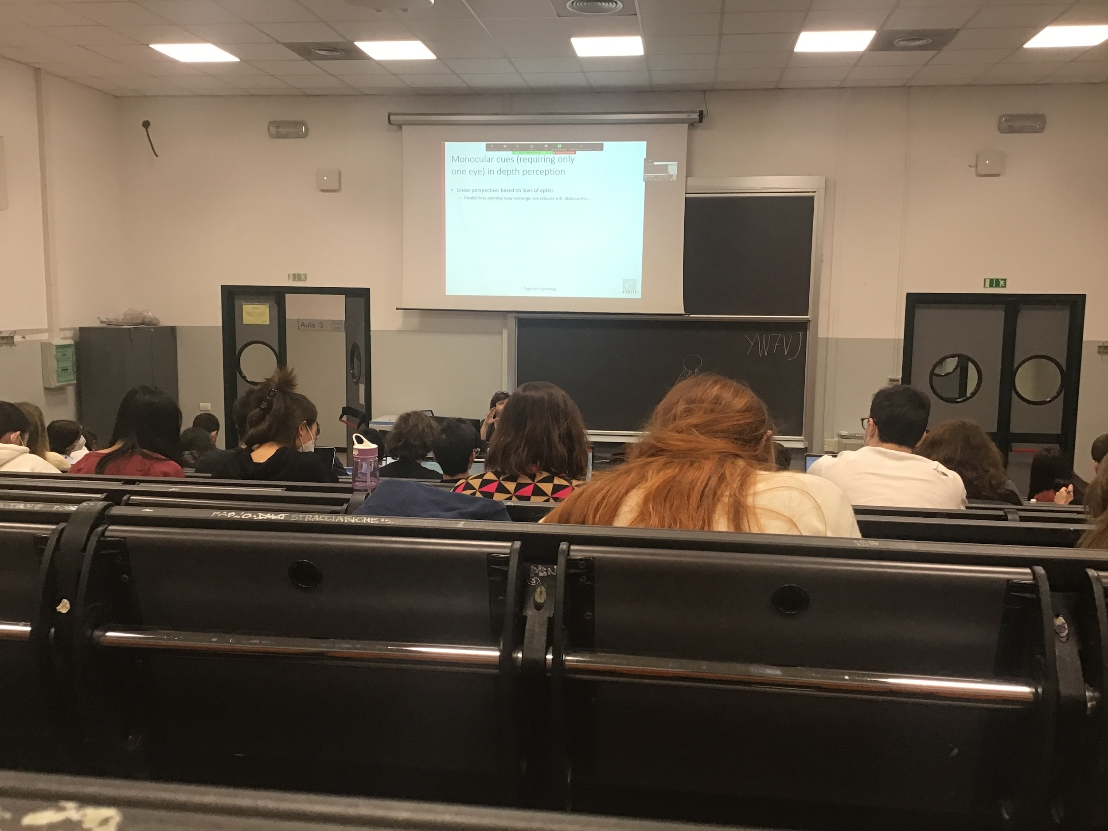

Eye is an optical system.

The environment is projected on the surface, lines that are parallel in real life, converge at the infinity.

The converges is part of linear perspective

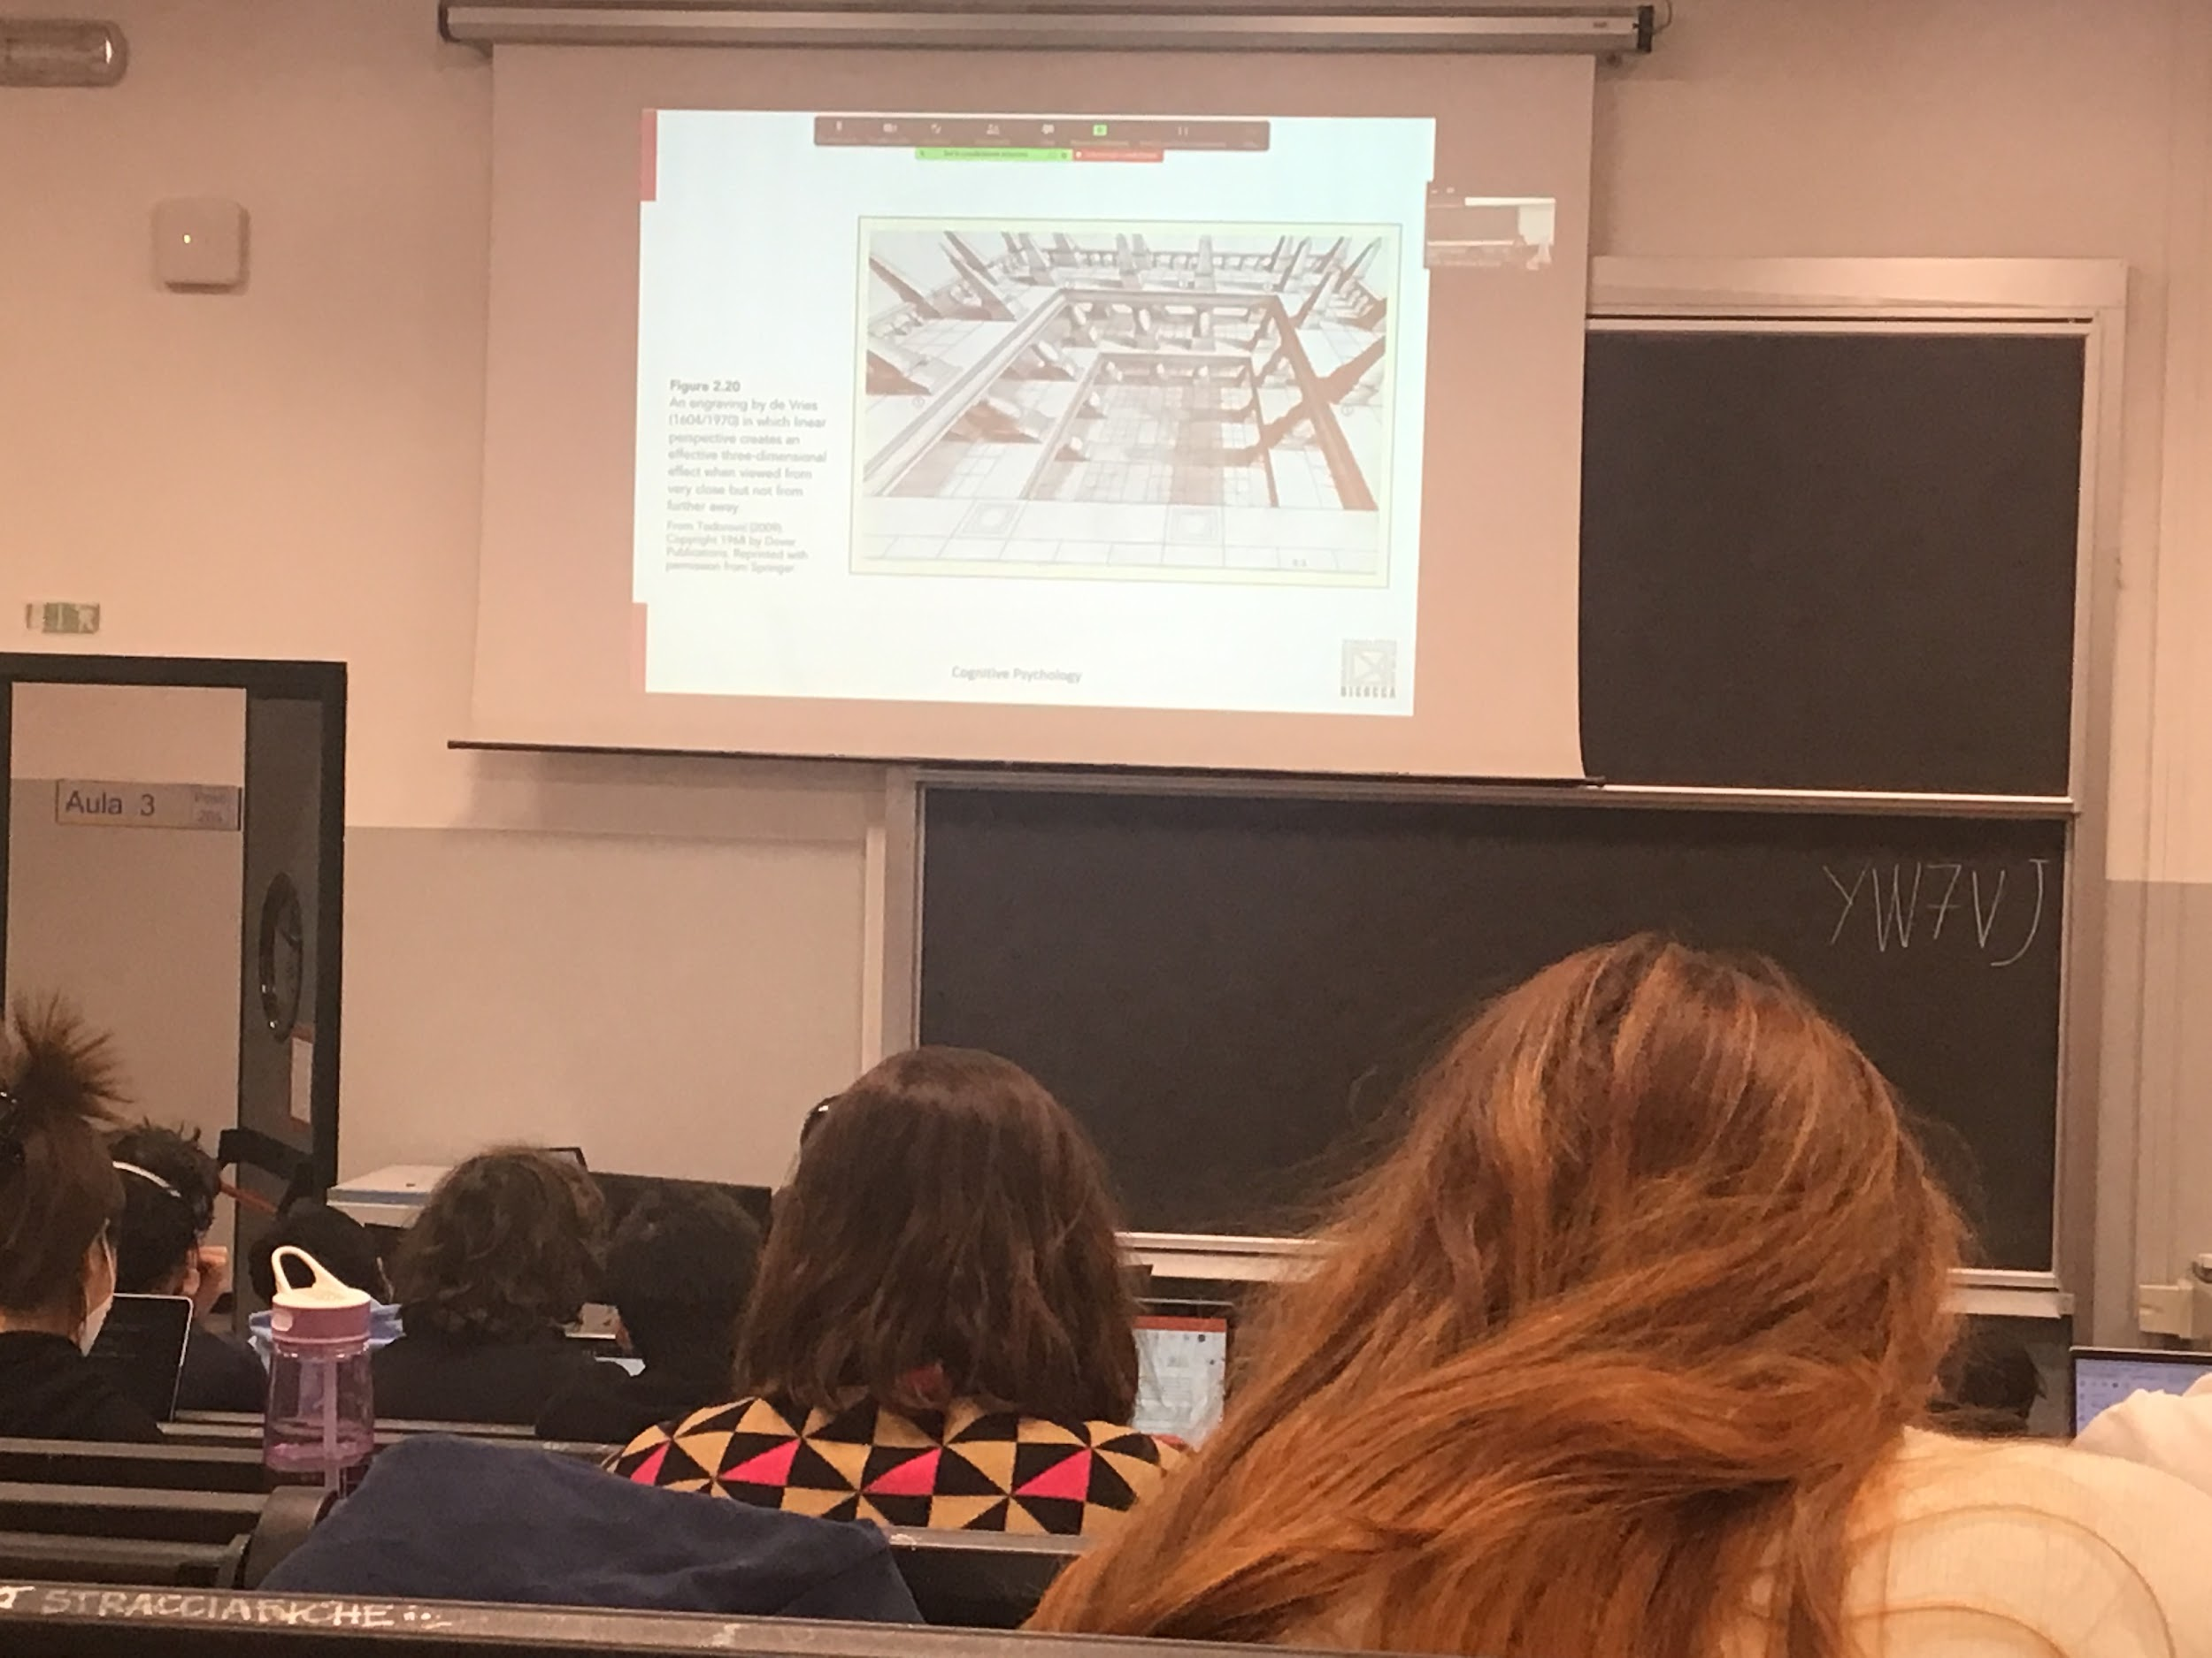

Linear perspective to induce a sense of depth

Need to have a focal point to work well

If you are not looking at the paining from the exact position you have a difference (and less) sense of depth

In real life we don’t have this conditions

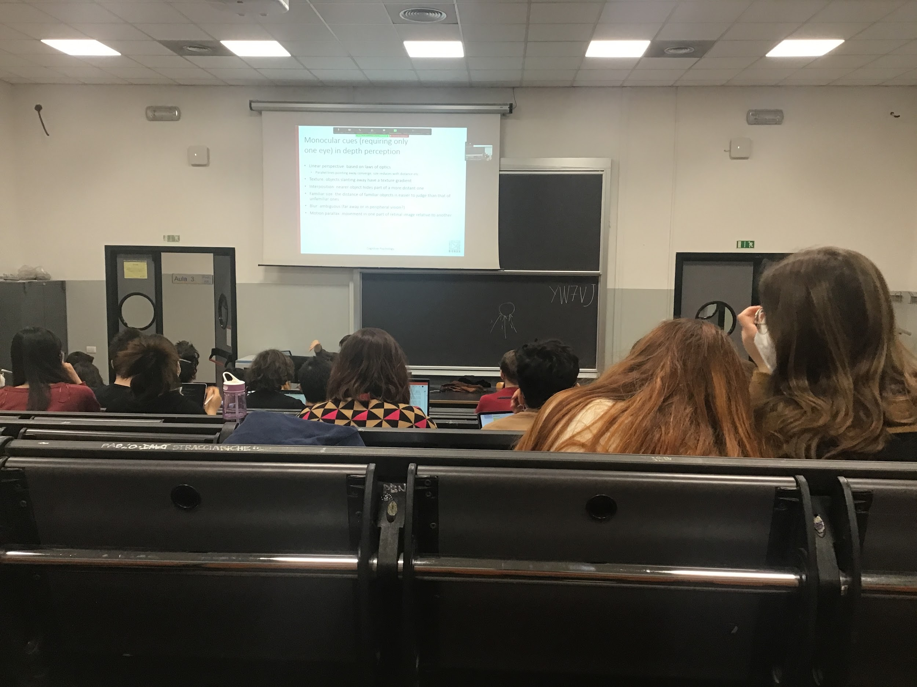

Our brain receive informations that comes from the eye

Texture: many object are done in different parts

Pattern of object of the same size, the texture become smaller and smaller together if you see further

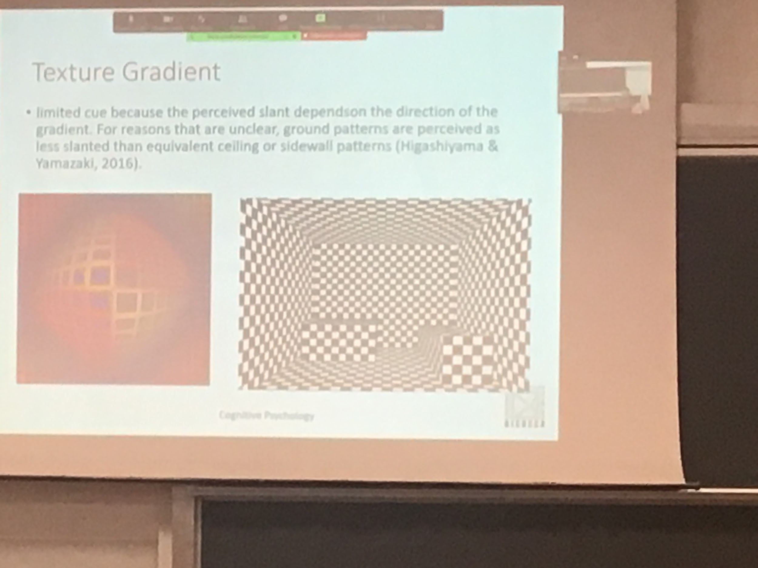

We don’t have lines that describe the object, but is the change in the pattern, texture mixed up with linear perspective

Texture gradient is not so reliable.

Another clue is interposition

We know people are closer and farther person because people in front seem bigger and block the people behind. Most of the objects in our environment are non transparent, block lightrays

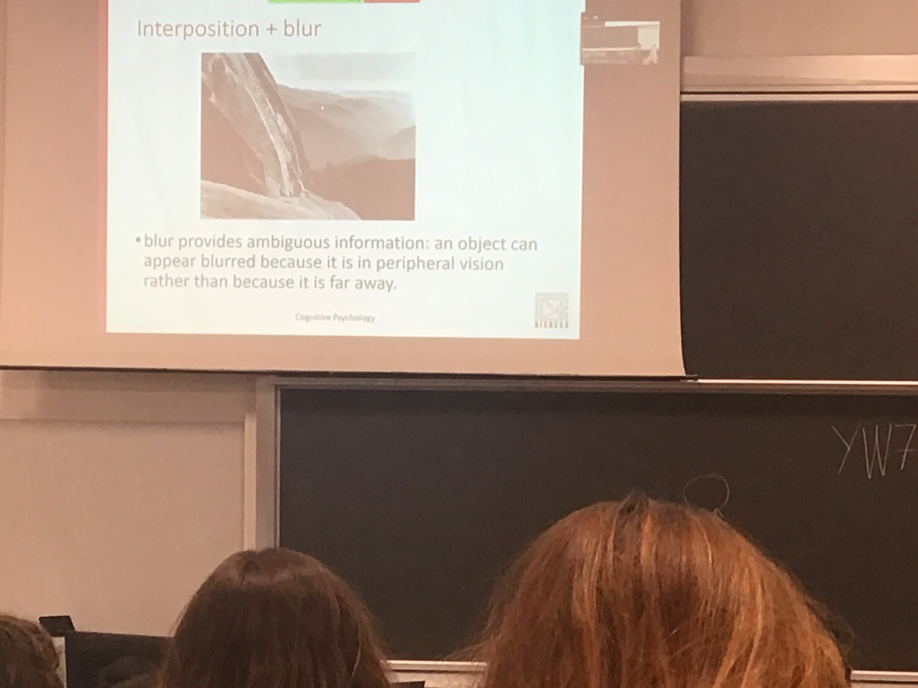

Interposition is a string clue

Our brain know that object are not transparent

In my mental representation even if you look at a people after a desk you know is complete

Blur is a clue that gives ambiguous information. If you look at the orizont part that are blur are far away. Lights need to travel a long way

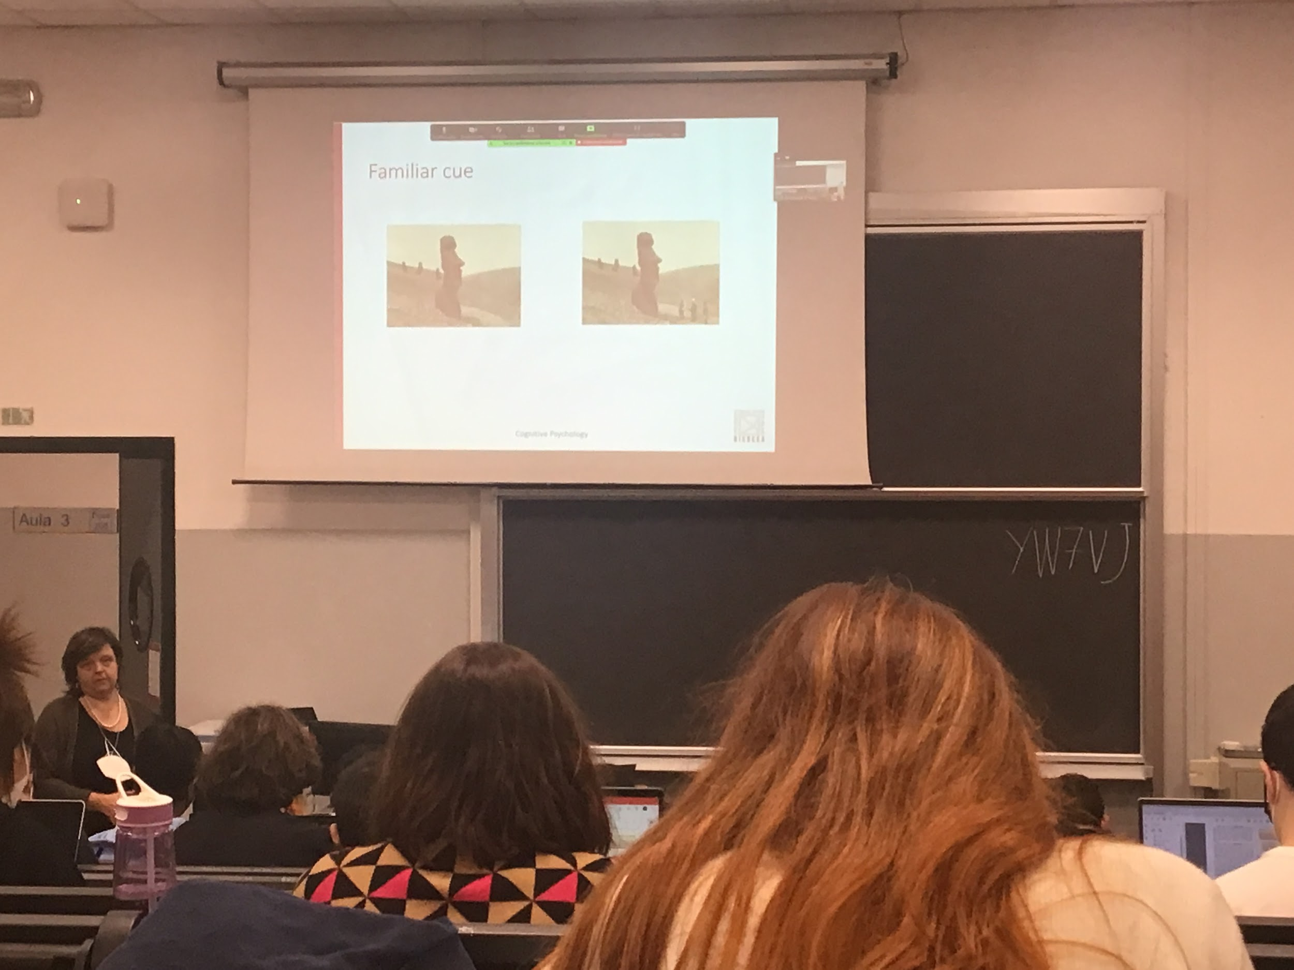

Familiarly

Easter island statue. We don’t know how big the statues are, but if someone is close by we have an idea

If we have a reference point the sense is different

The one above are clauses relative of monocular and static, no need to moving

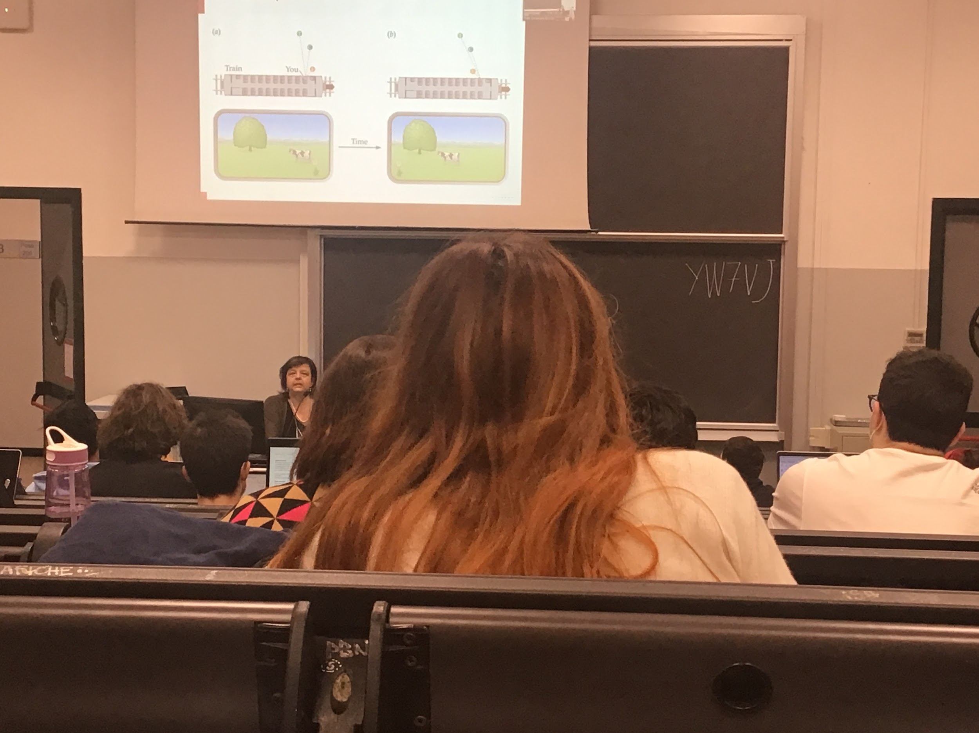

Motion parallax

If you are sitting on a train we see that the objects closer yo use are going very fast

If you look at the mountain they seems not moving

**Part 2**

[**Esperimentipsy.unipv@gmail.com**](mailto:Esperimentipsy.unipv@gmail.com)

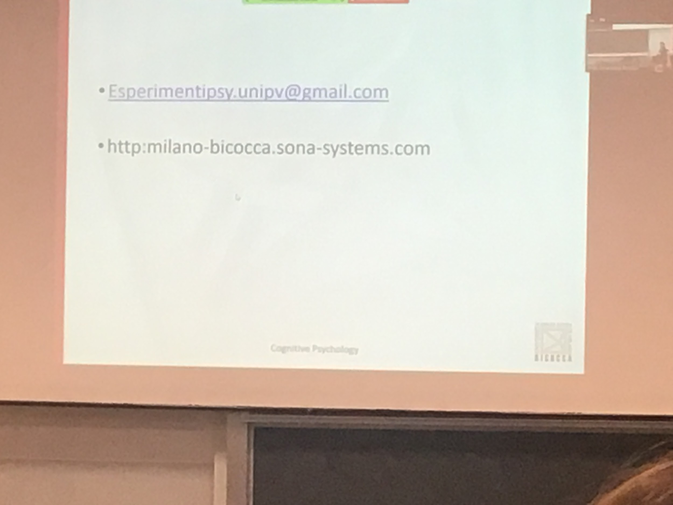

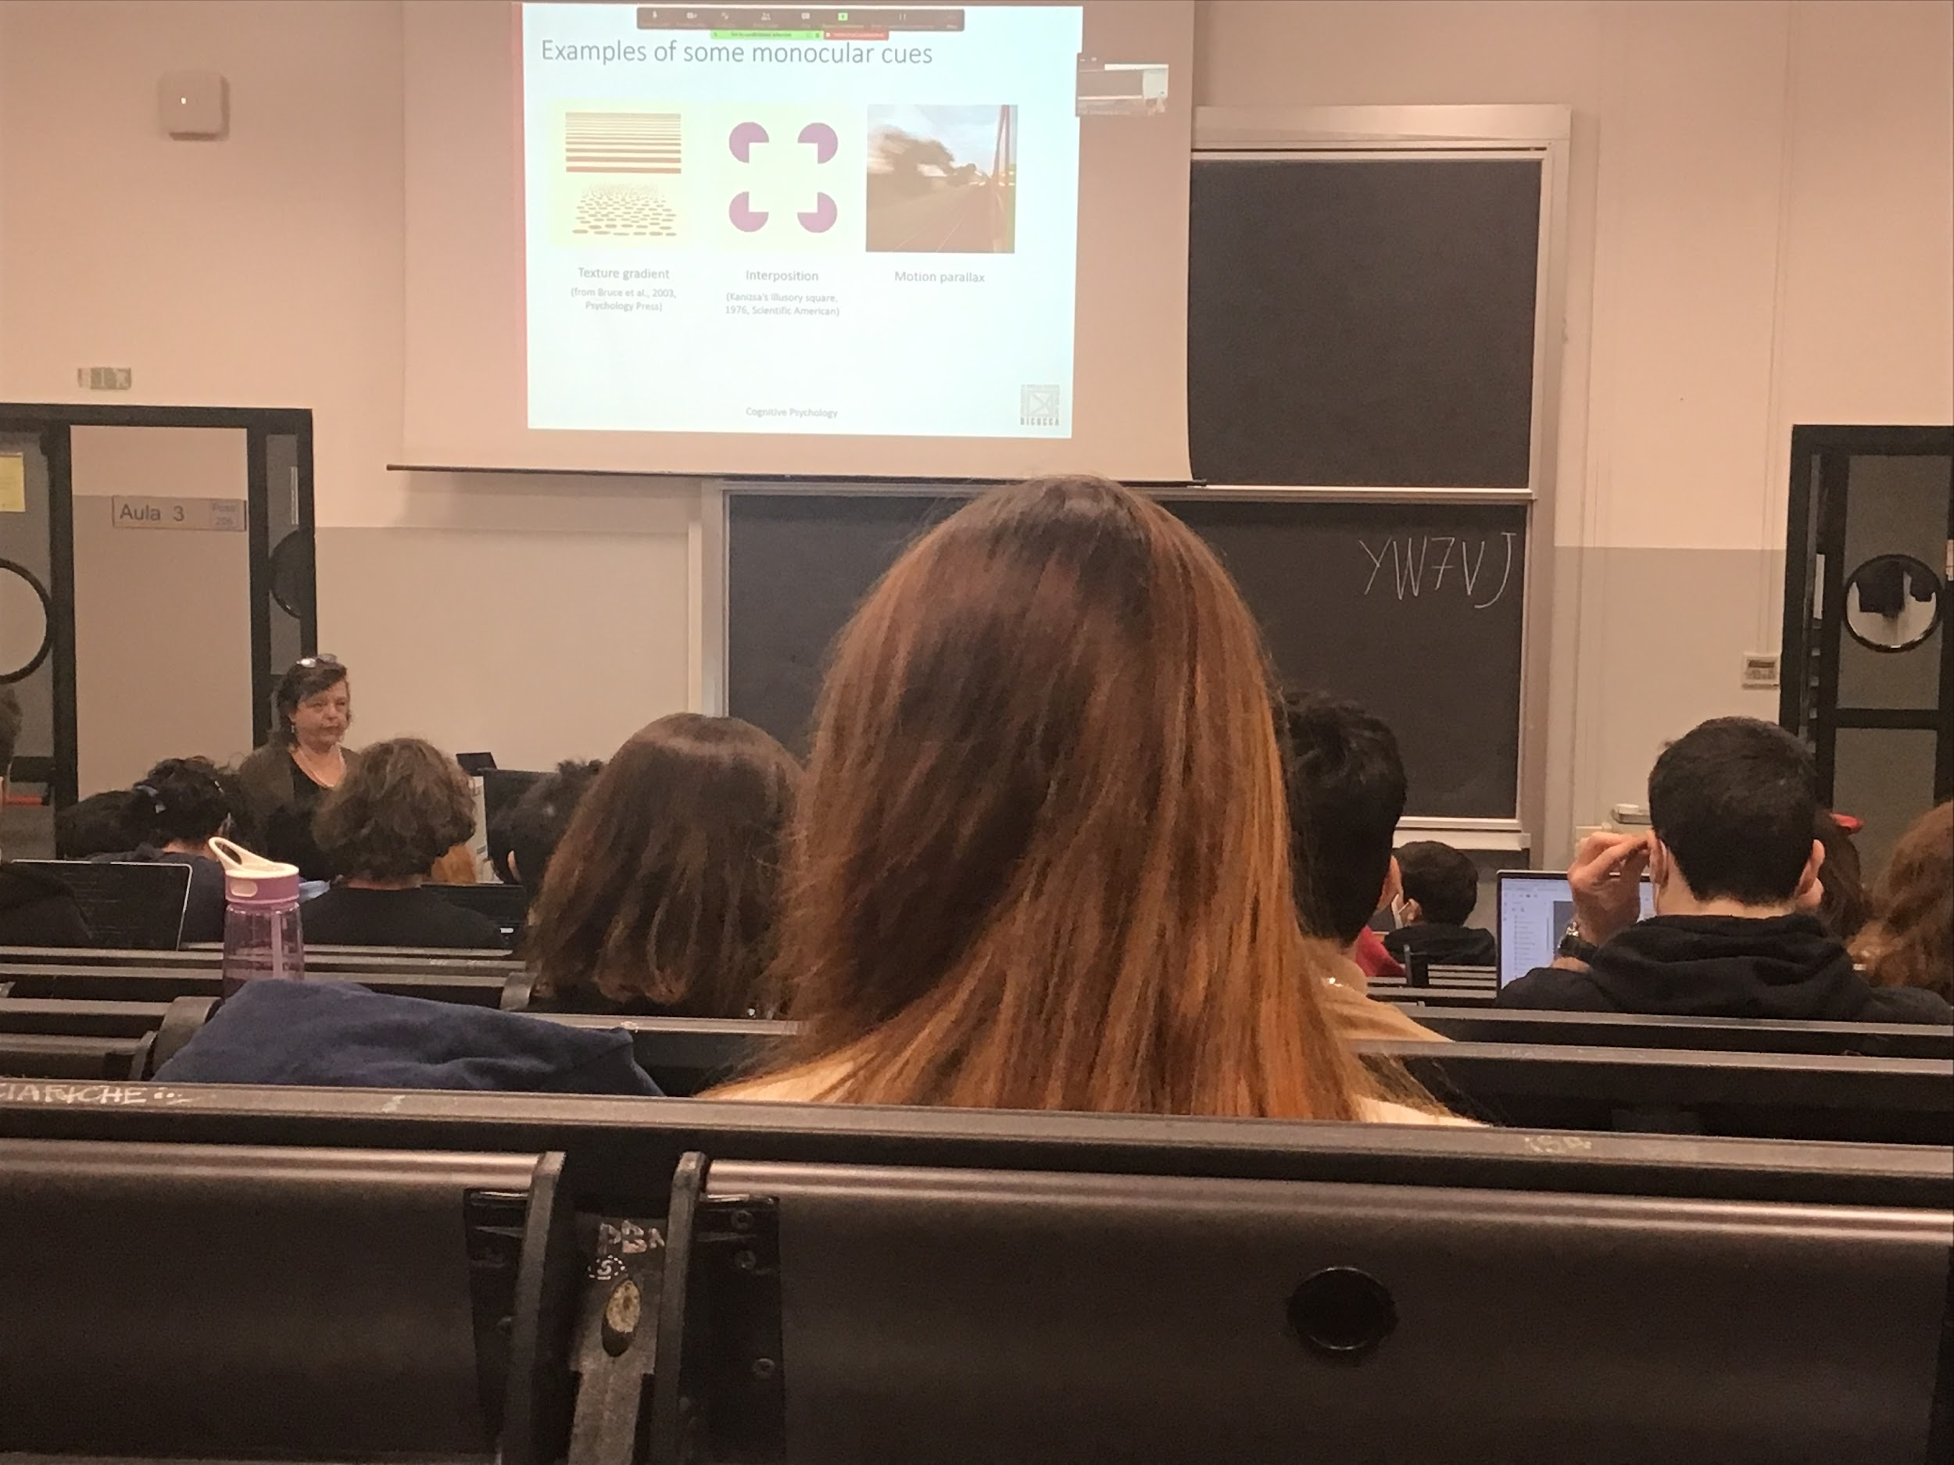

Idea of a square, try to complete borders and create the perception of a square

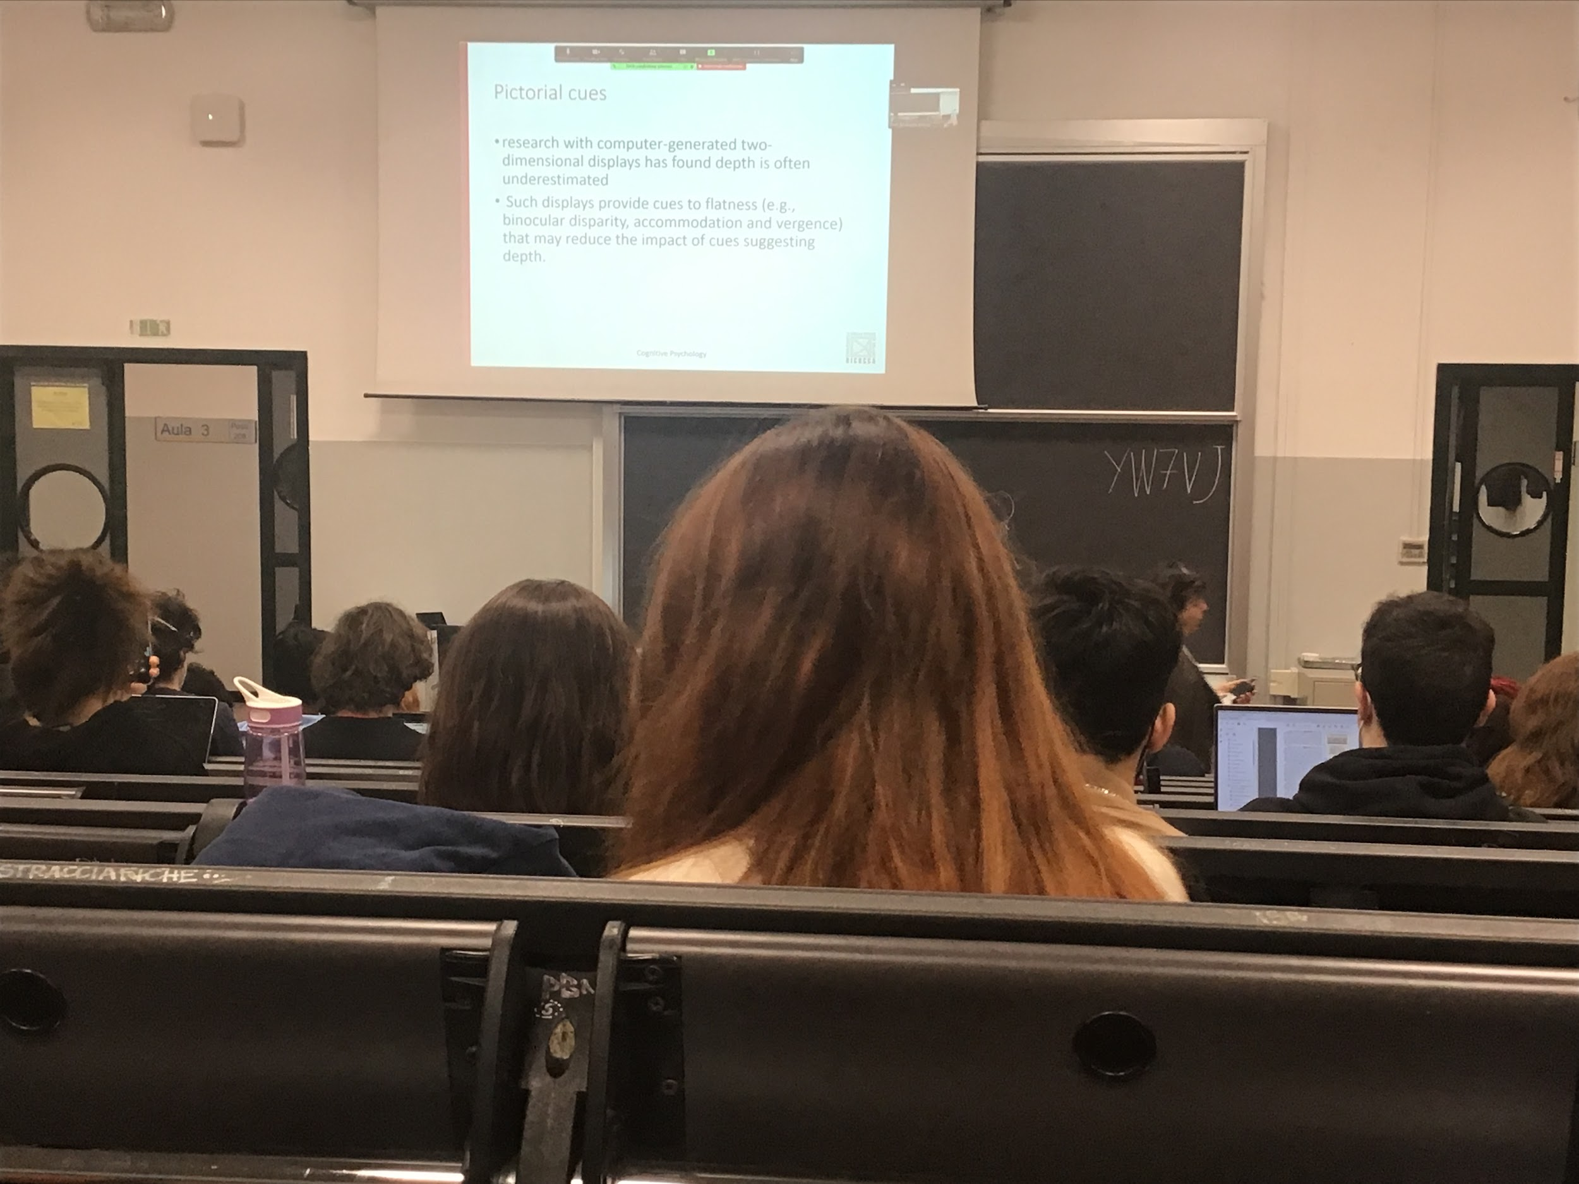

The displace gives informations about flatness

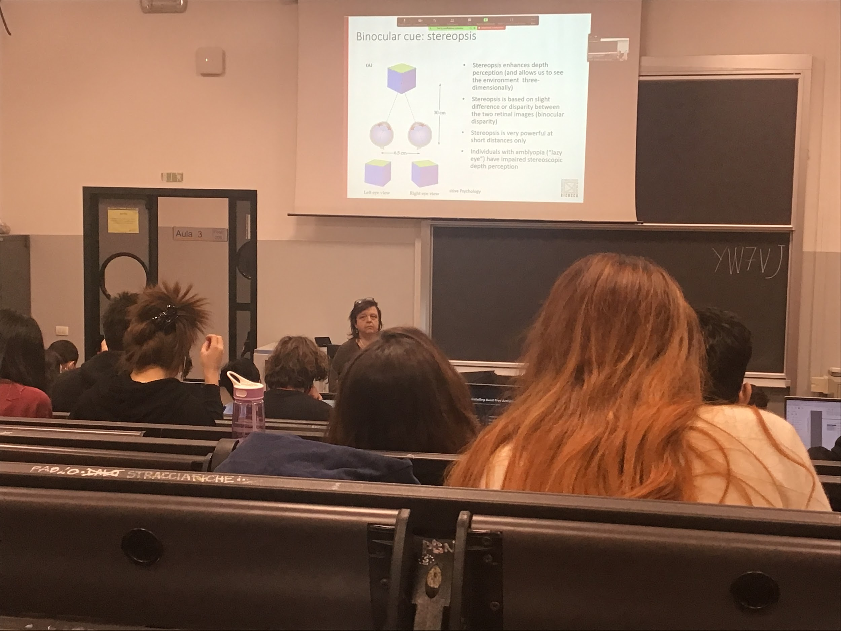

There are people that do not use this clue

To understand what stereopsis is the difference between watching a movie in 2D and 3D

Most of us have a strong feeling of depth.

The image taken by the two eyes the identical objects are different

The only not difference between the two view is a point (on black)

Brain has cells in v2 where what comes from the left and right eye is compared.

Very powerful only in short distances

People that difficult in muscle movement in one eye (lazy eye) the muscle are not so precise

The difference is not constant

There is a difference between perception and view

View: recording of a pattern of activity that is out there

Perception: building up representation of what is out there

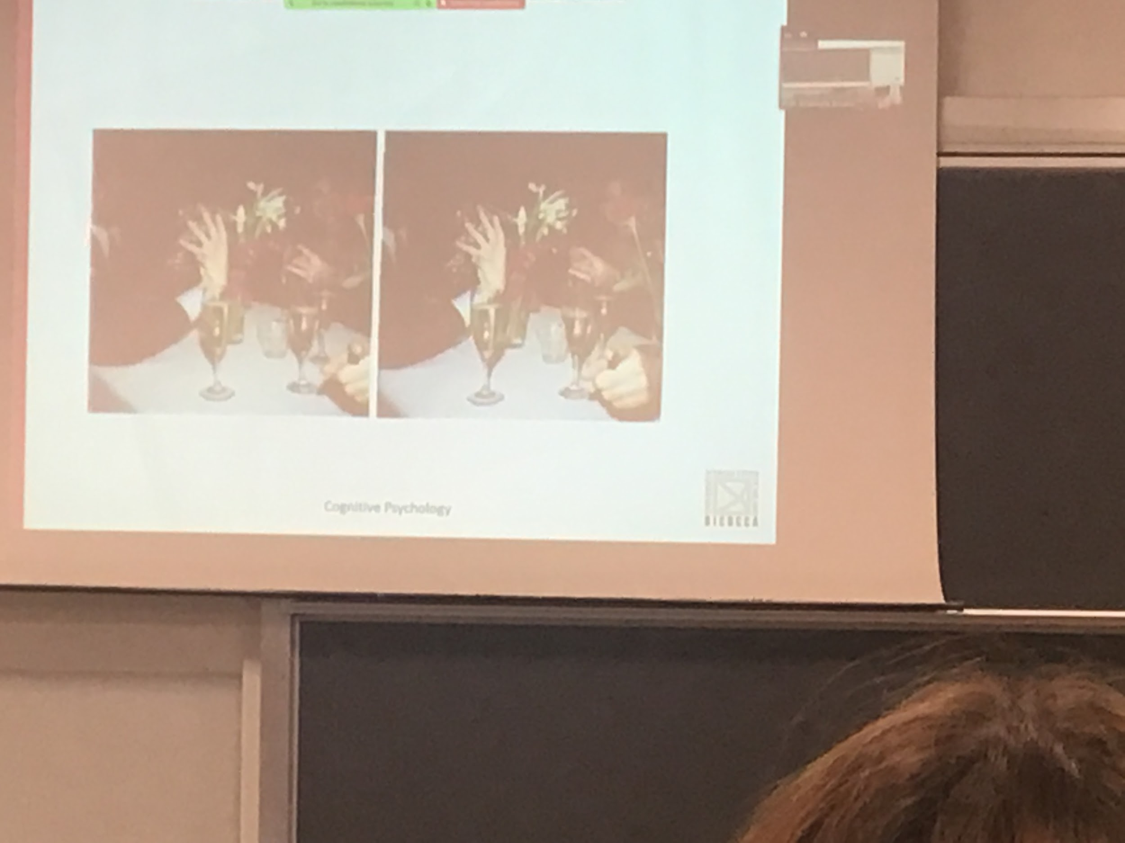

What the system f compute is the relative position of the face in the two pictures

Larger differences means further away

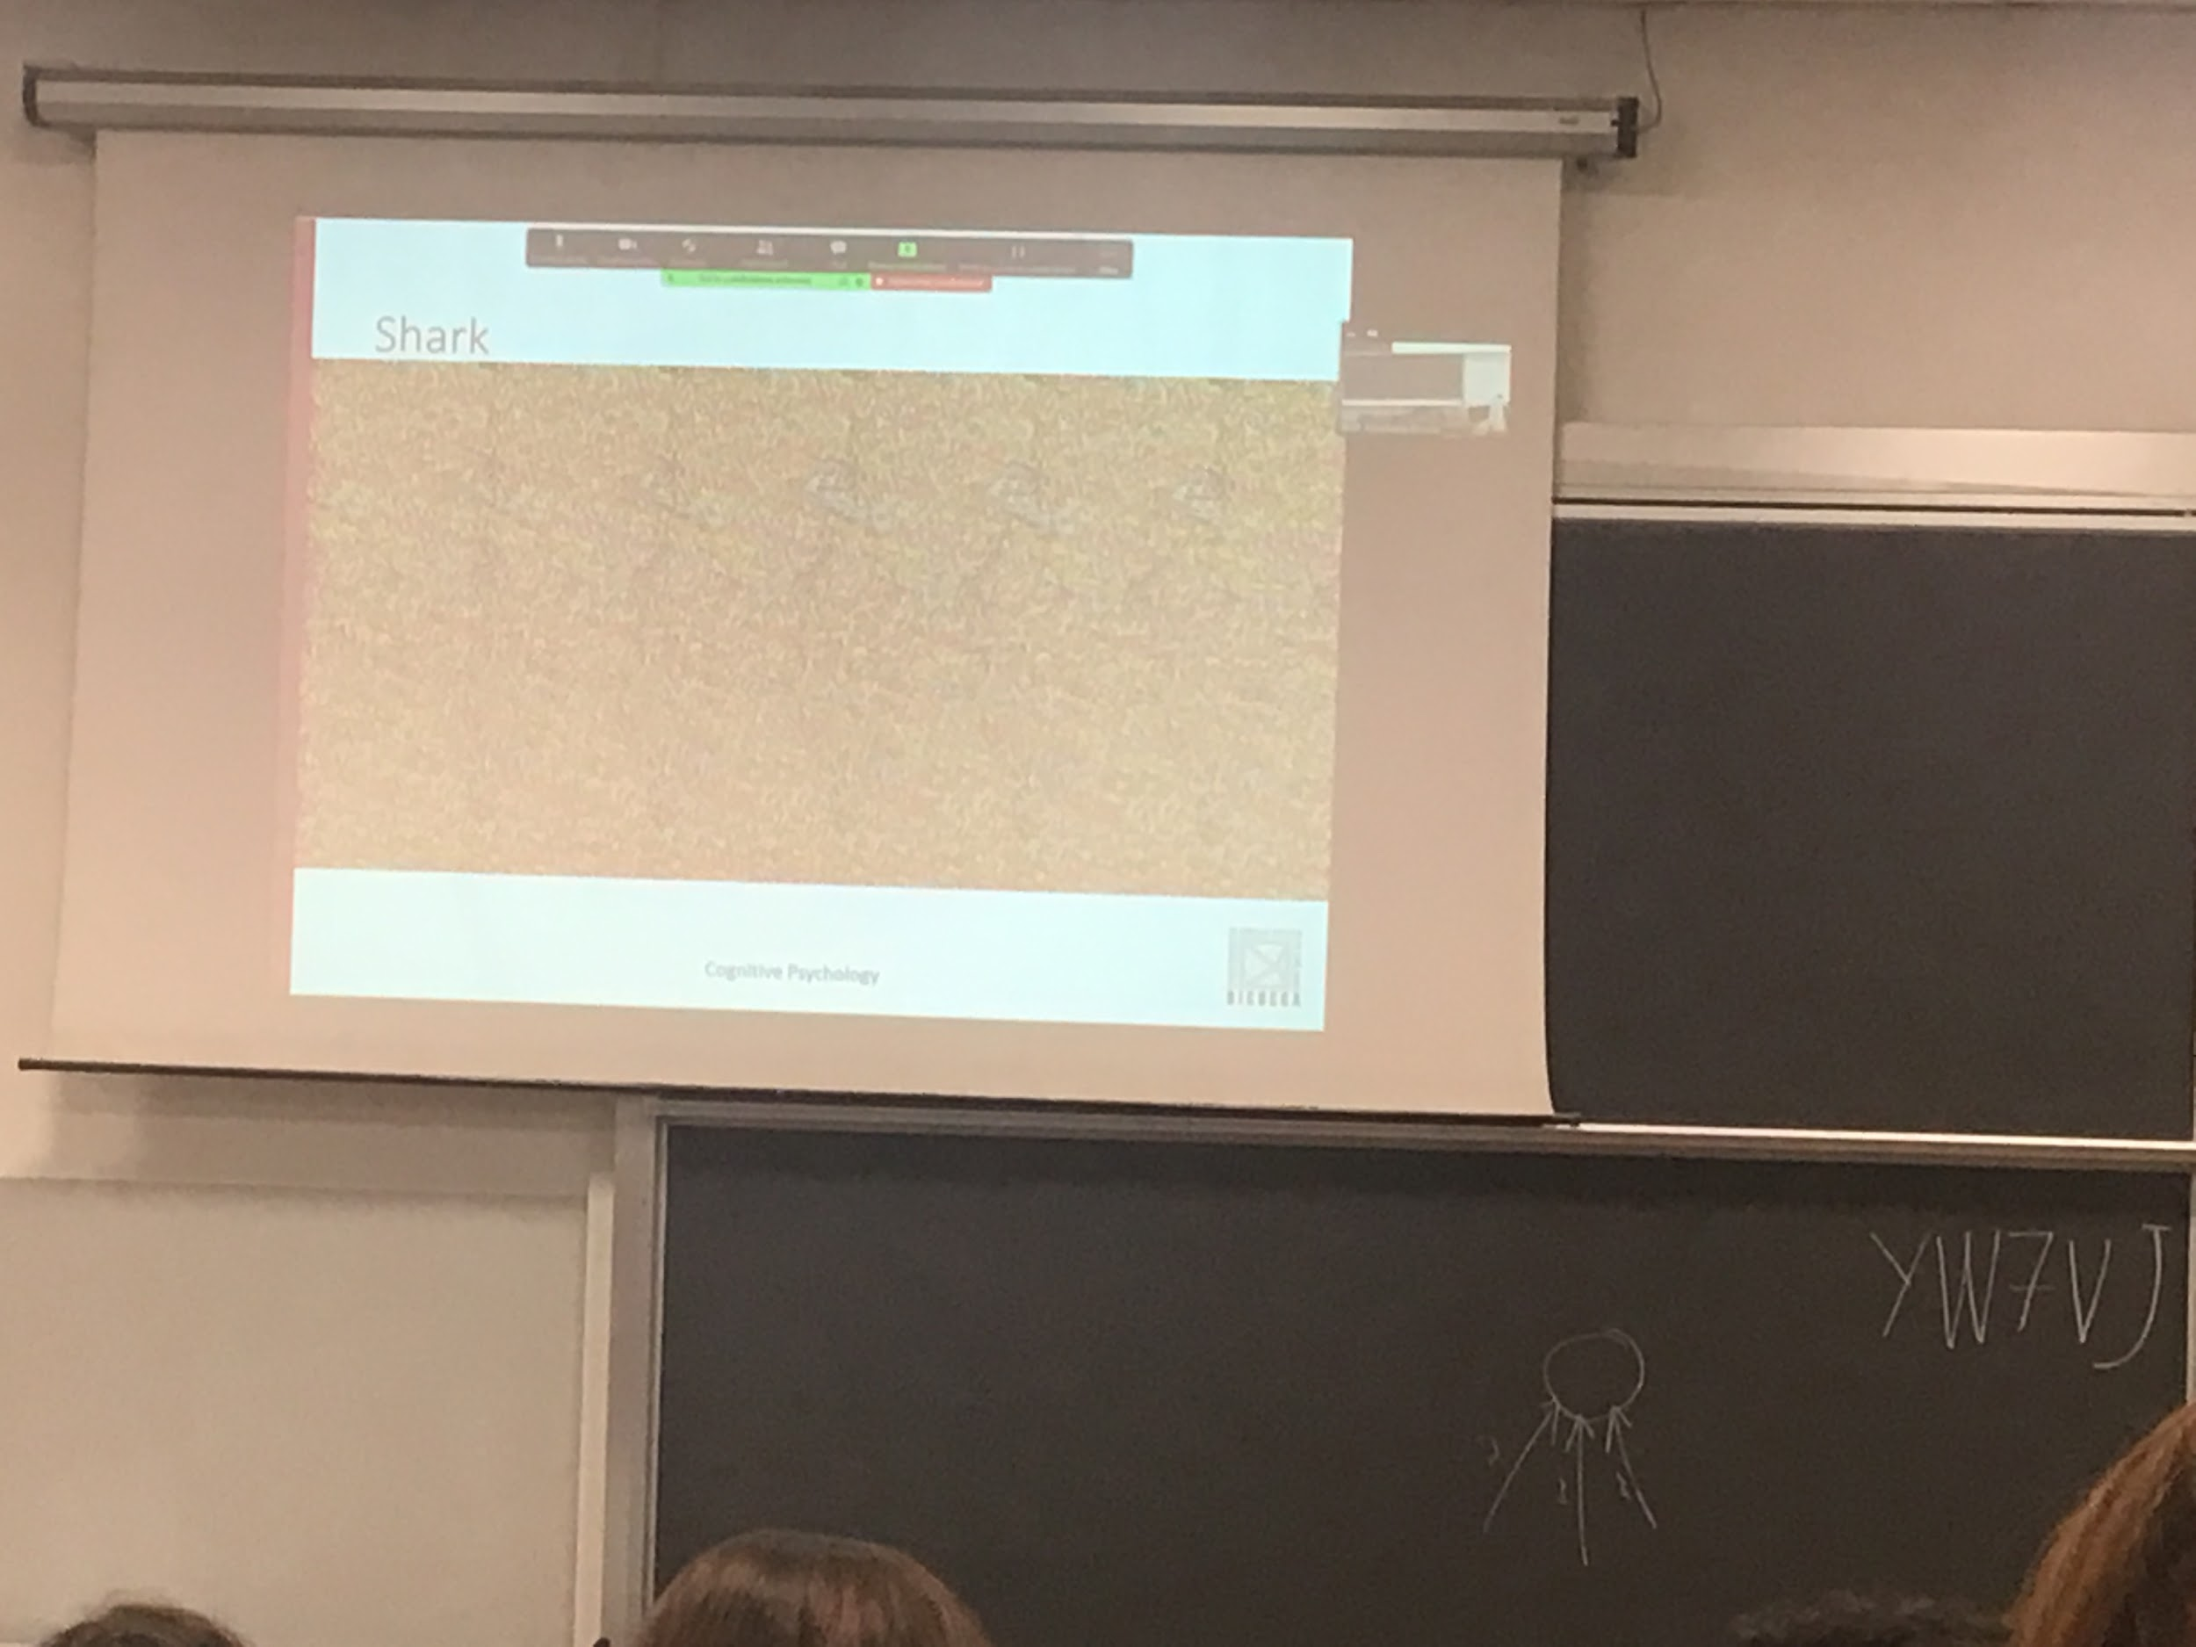

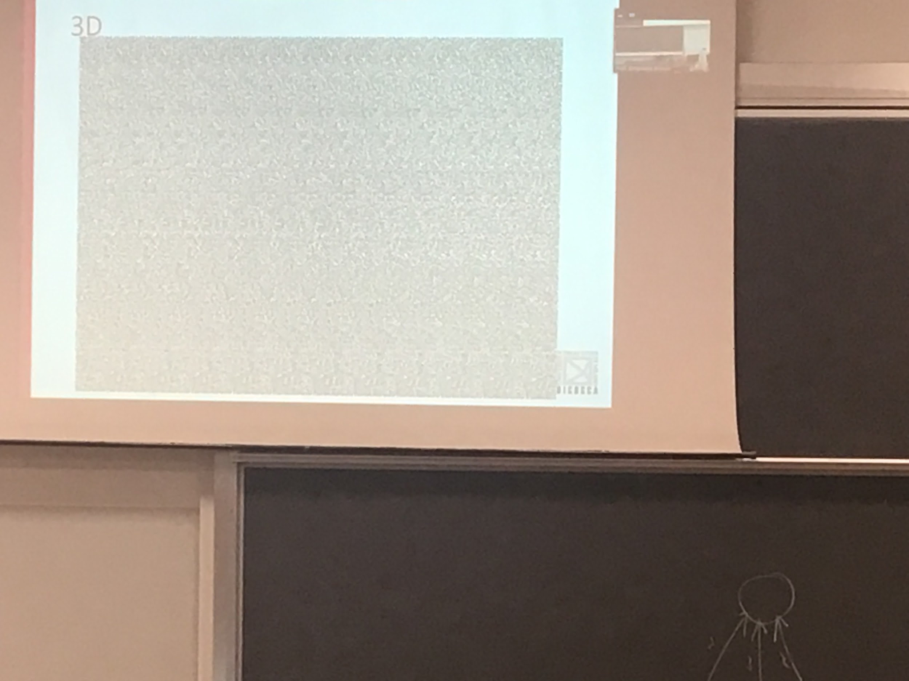

Called auto sterò graph, done with random dots reproduce in position so that you can perceived depth when there is no depth

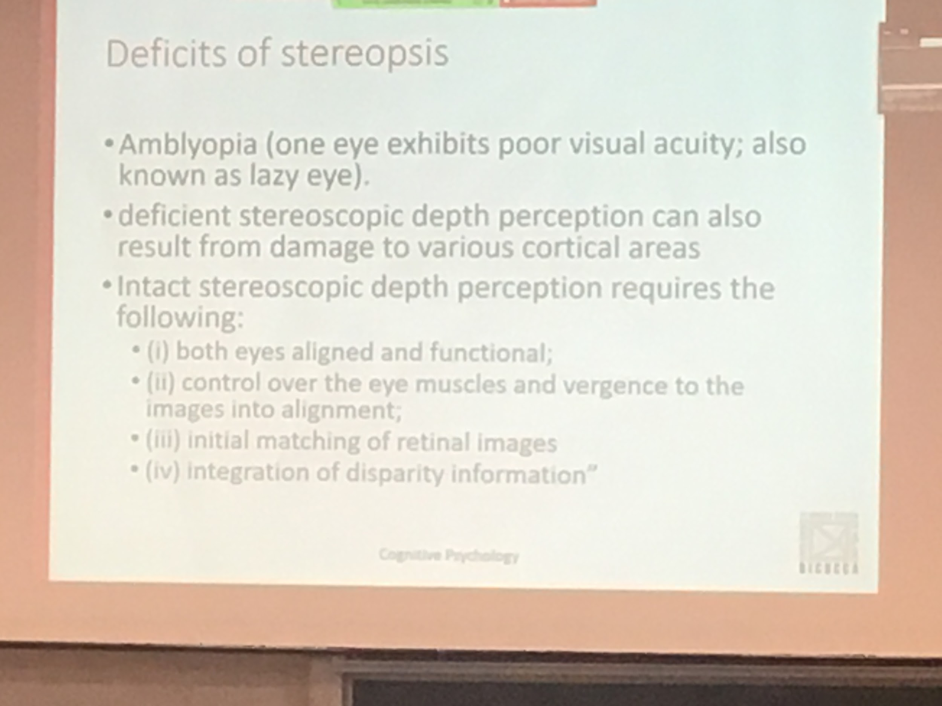

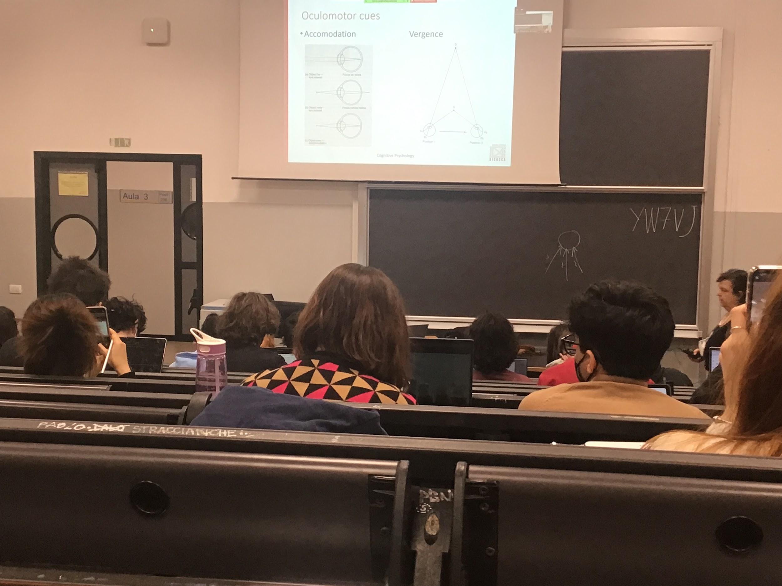

This cues work only to the object you are focusing

If you are looking at one specific point the size of the lens changes

After a certain distance the lenses relax

When I am focusing close or far away

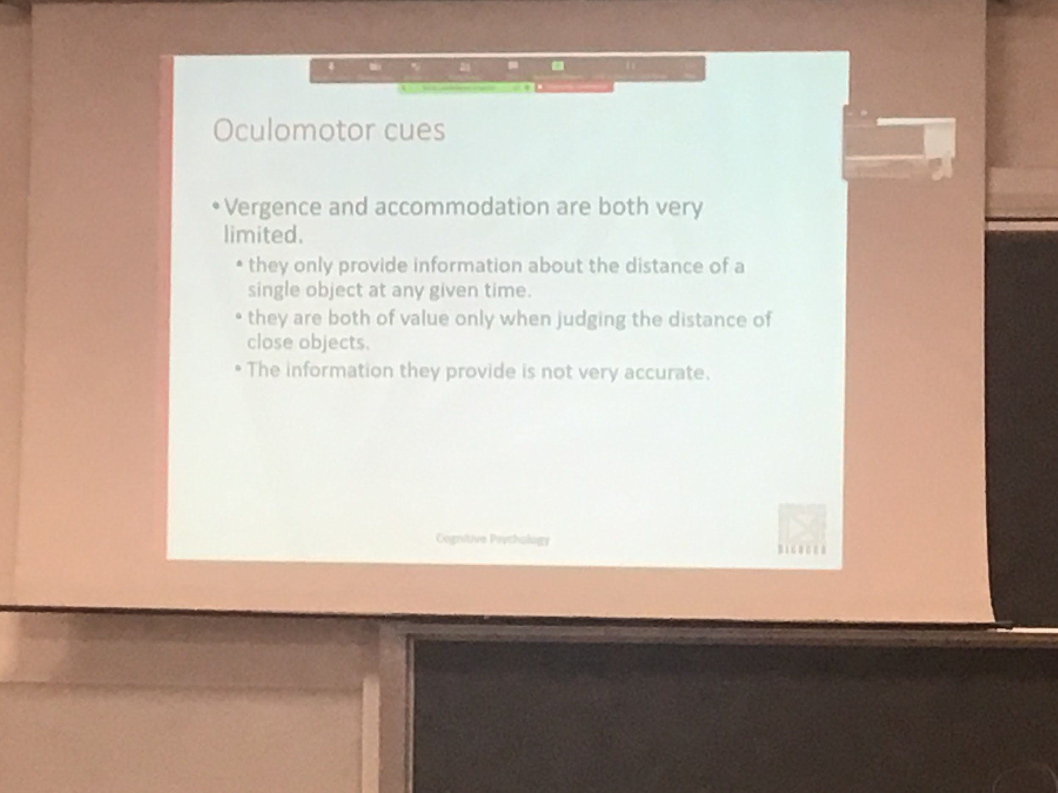

Only work for the object you are focusing on

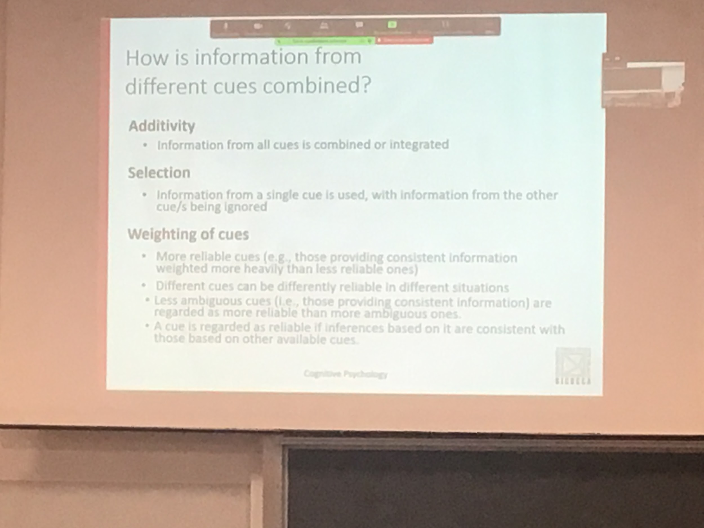

All his clues are presence most of the time

But sometimes they give contrast information, how to combine them? There are different hypothesis

Additivity: all clues are use, all give an estimation

Selection: use only the most reliable clue

Weighting of cues

What is reliable is not always the same clue (depends on the situation)

First one is a statistical condition, using Bayes rules. What is the probability that this level of depth is there? What is the probability that the object is 20m from me? Keep the highest probability of the distance from an object

Bayes rules combine the data and probability, know from experience, use idea of familiarity

Ideal-observer model:

How would an ideal observer, what is the optimal combination of clue that will gives me the best integration

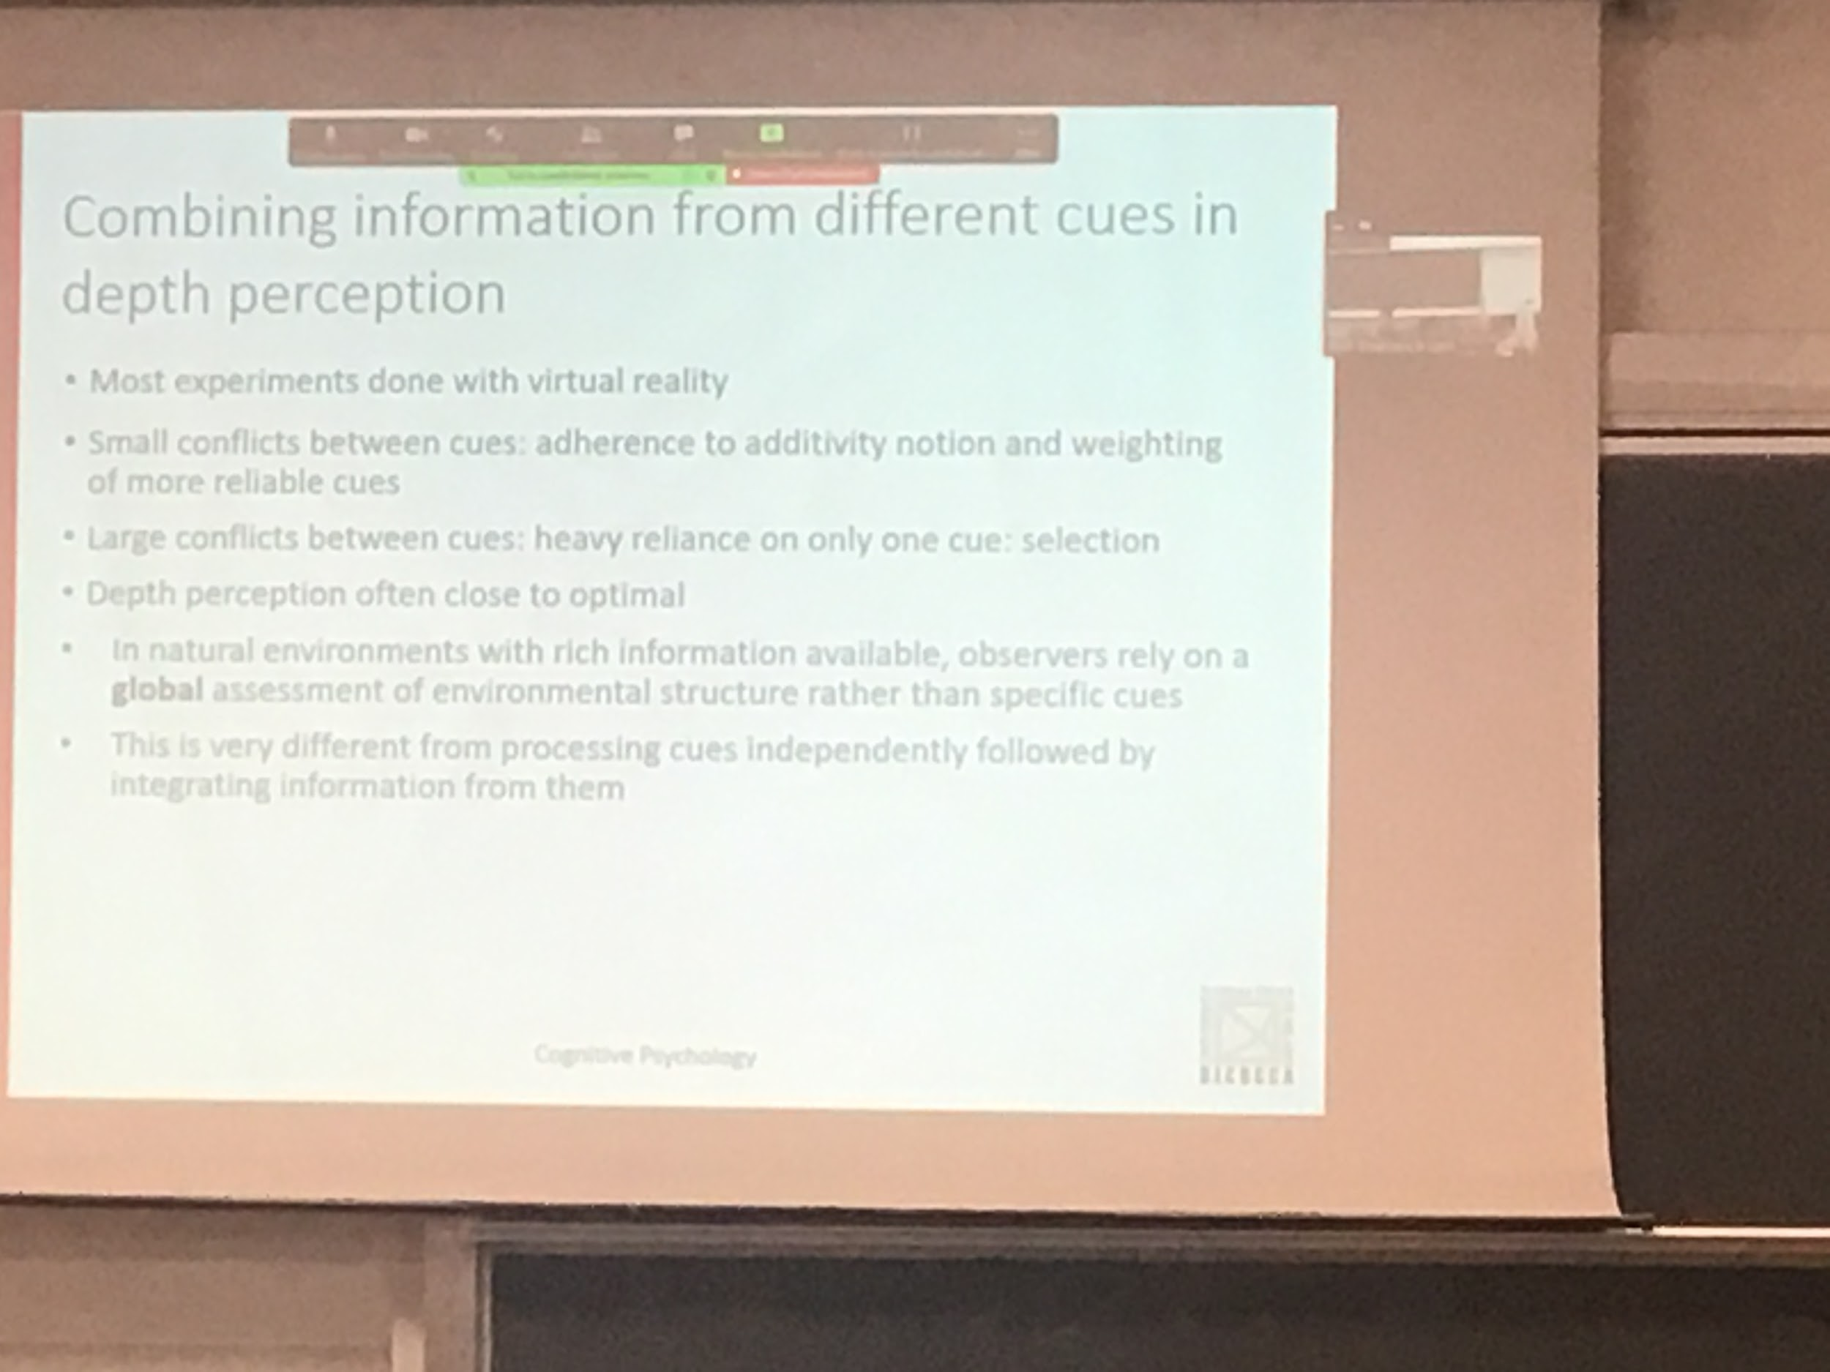

When all the clues more or less gives the same results I +completare

When there is a large object we peek the one that seems more reliable

We are good at perceive depth, survival skill needed

In real life the computations seems not too detailed

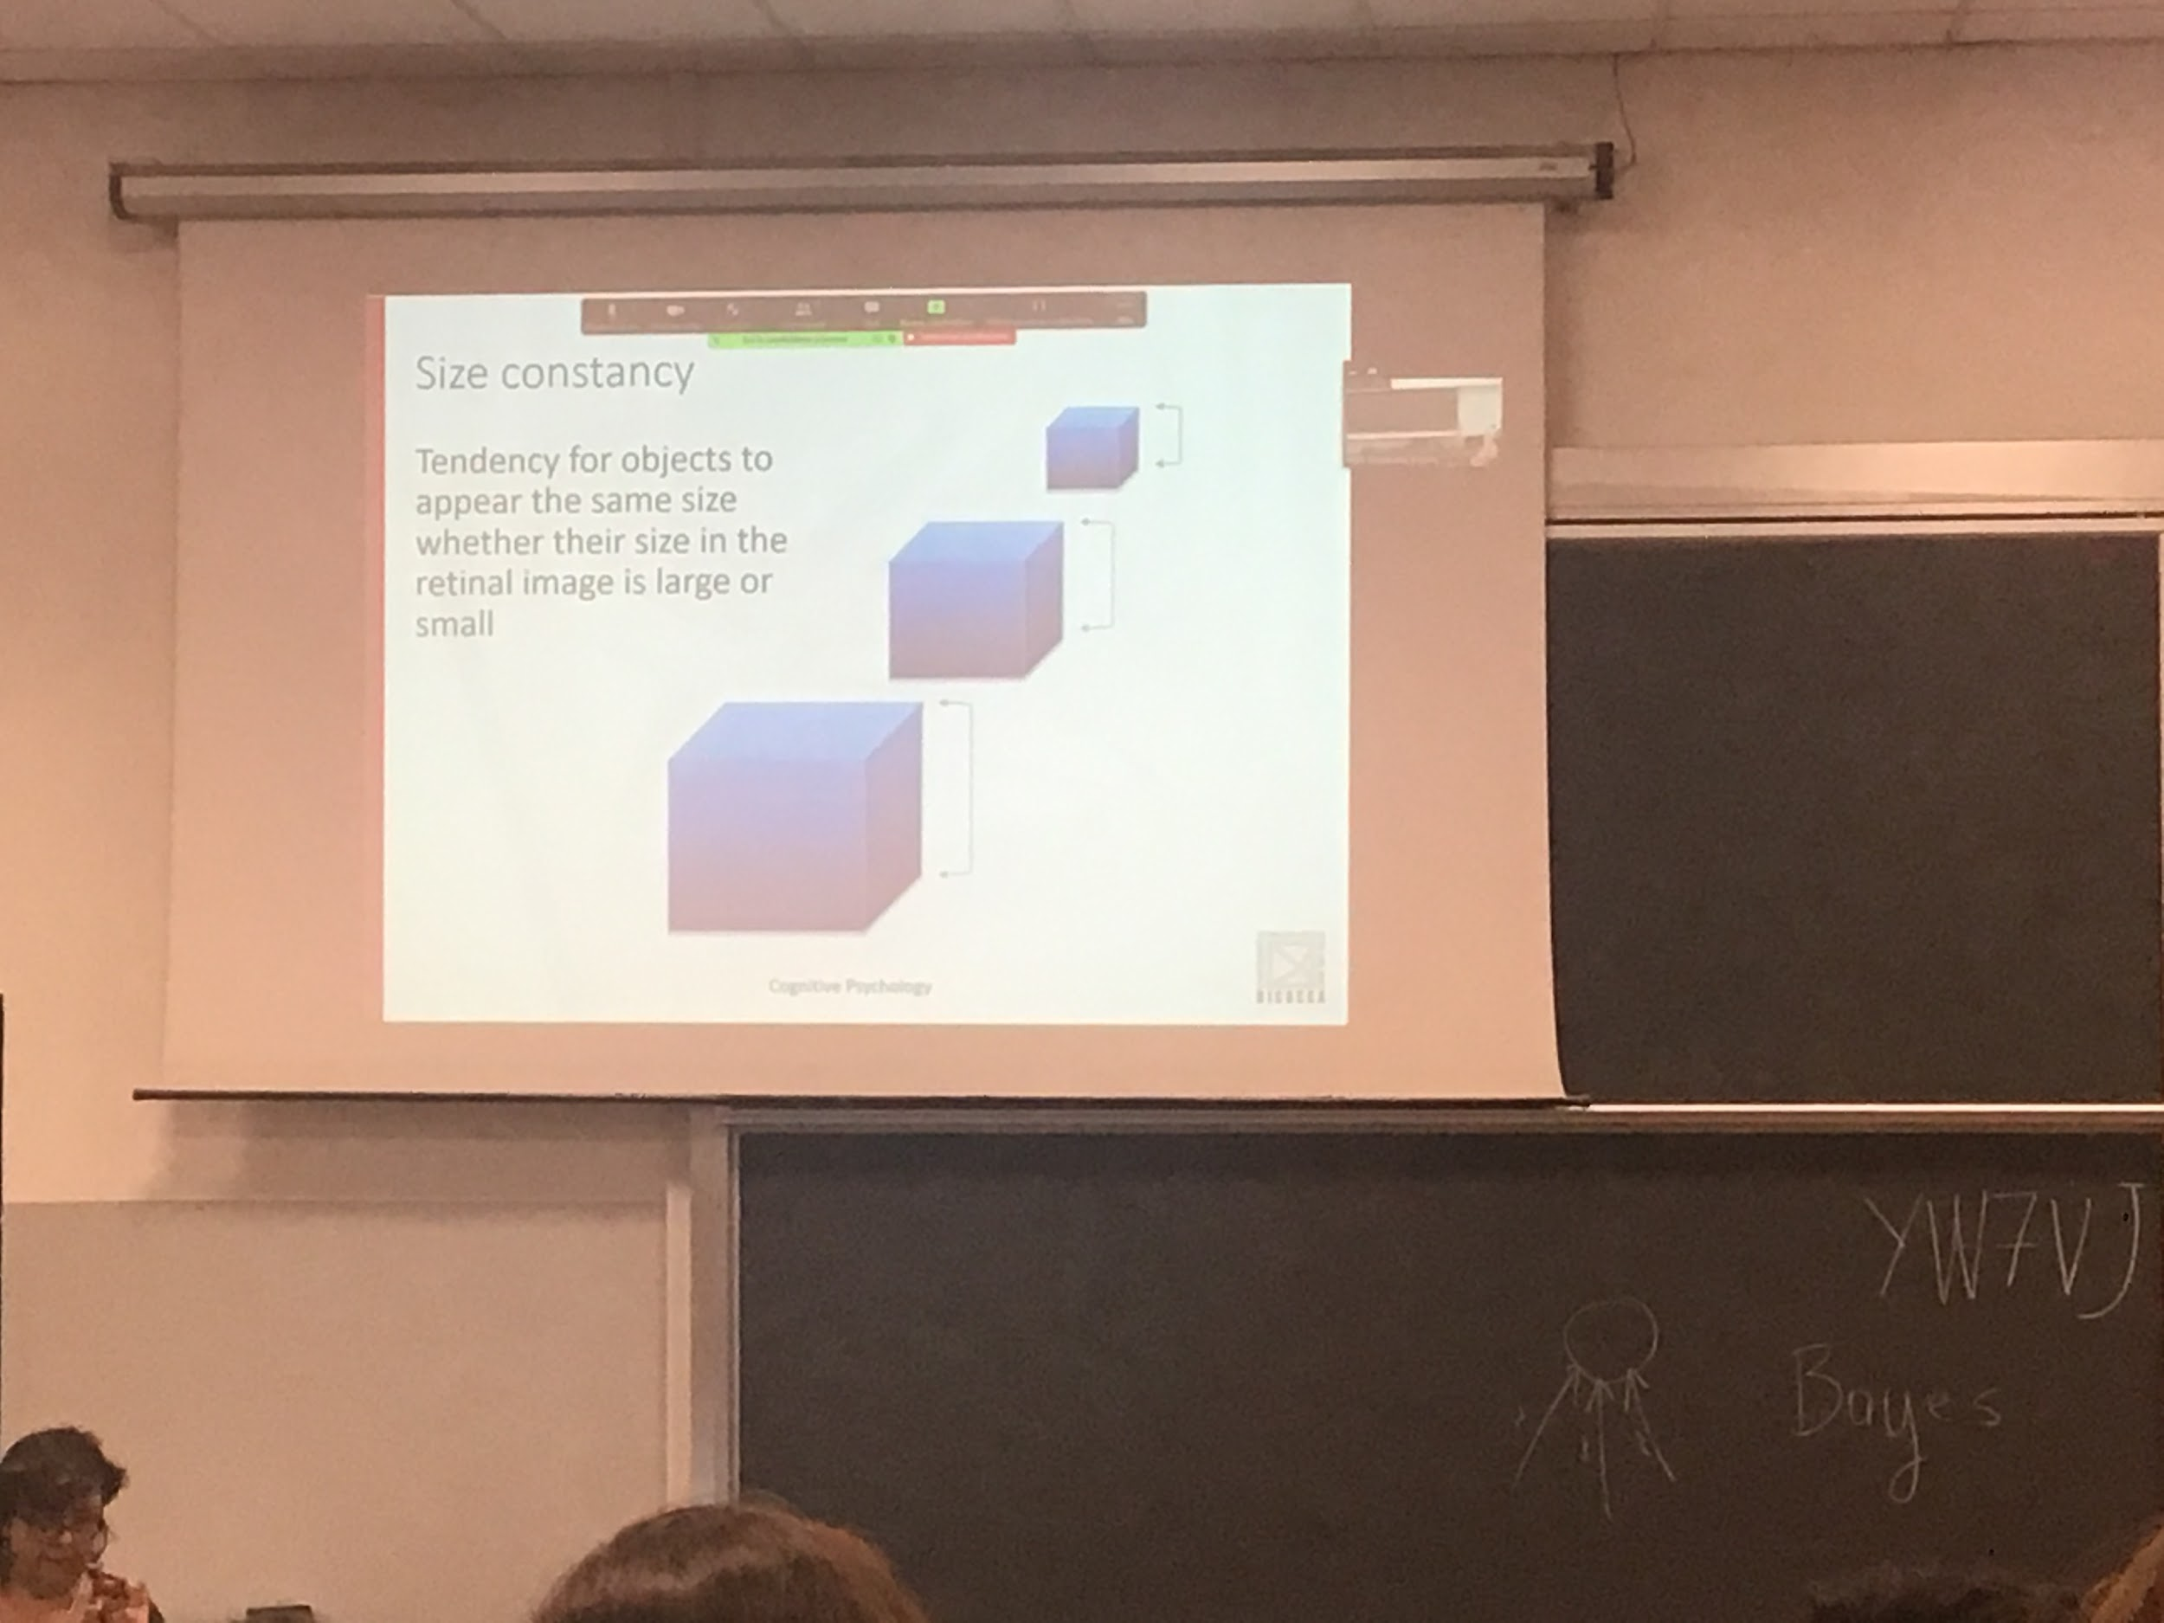

One thing that the system must do is to use depth to compute the size.

The object further away from me has a smaller image on the retina??

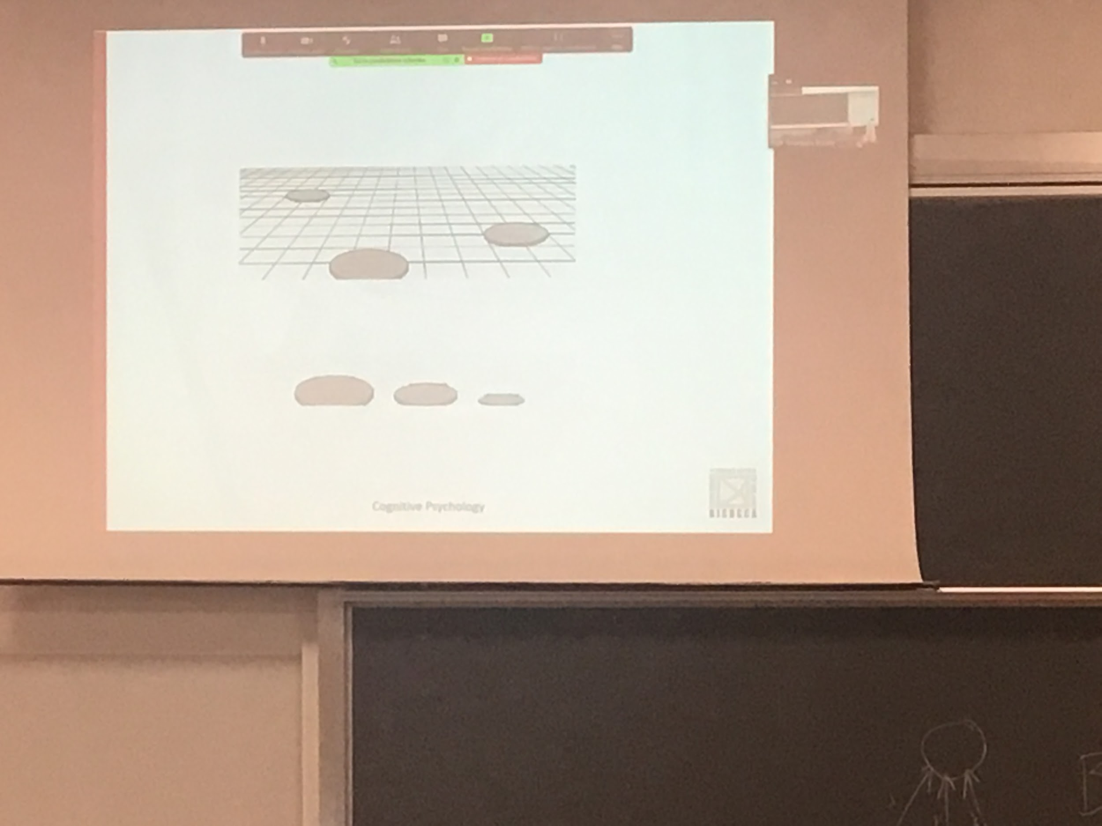

Our perception is that the three circles have same size

Our brain uses the other information (the pictures clues) to predict at what distance the object are

Our view is that the three things are different